

**Data Science and Analytics for Healthcare Market Trends**

**Name:** **Hritick Jha**

**ID: 77356744**

**Supervisor: Shiva Prasad Nepal**

**Table of the content**

**Introduction ……………………………………………………………………7**

**Review of literature ……………………………………………………………8**

* **Data science in healthcare market analysis……………………………8**
* **Healthcare predictive Analytics….…………………………………….8**
* **Interactive Dashboard for Data-Driven insights………………..………8**
* **Challenges and future Directions……………………………………….9**
* **The possibility of digitizing health care …………………………………9**
* **Web-based apps for healthcare ………………………………………9**
* **Web applications and the challenges of behavior modification…………9**

**Review of Technologies………………………………………………………10**

* **Programming language …………………..……………………………10**
* **Python ……………………………….……………………………. 10**
* **Data Analysis & Visualization Tools …………………………………10**
* **Pandas ……………………………………………………………10**
* **Numpy………………………………………………………………11**
* **Matplotlib……………………………………………………………11**
* **Seaborn………………………………………………………………11**
* **Plotly………………………………………………………………….11**
* **Machine learning Technologies ……………………………………….11**
* **Scikit-learn ……………………………………………………………12**
* **Tensorflow…………………………………………………………….12**
* **Data sheet……………………………………………………………….12**
* **Excel…………………………………………………………………12**
* **Version control and documentation………………………………………12**
* **Jupyter …………………………………………………………………12**
* **Web application for database………………………………………………12**
* **Php Application for databases …………………………………………12**

**Methodology …………………………………………………………………..13**

* **Preparation and Requirements Analysis…………………………………13**
* **Agile………………………………………………………………………14**
* **Research Design …………………………………………………………..14**
* **Design and Implementation………………………………………………15**
* **Collecting requirements information………………………………………15**
* **Analysis of requirements…………………………………………..………15**
* **Ethical considerations …………………………………………………….15**
* **Software requirements specification………………………………………16**

**Product Design ………………………………………………………………….16**

* **Introduction………………………………………………………………16**
* **Project planning …………………………………………………………16**
* **Gantt chart………………………………………………………………17**
* **Task sheet…………………………………………………………………17**
* **Timeline……………………………………………………………………18**
* **Use case……………………………………………..…………………….18**
* **Control Flow diagram…………………………………………………….22**
* **ERD………………………………………………………………………..24**
* **Wireframe Design …………………………………………………………25**

**Software Requirements Analysis……………………………………………….. 36**

* **Jupyter notebook…………………………………………………………37**
* **Vs code (visual Studio code ) ……………………………………………37**
* **Php……………………………………………………………………37**
* **Html……………………………………………………………………37**
* **CSS……………………………………………………………………37**
* **JavaScript……………………………………………………………….38**
* **Python………………………………………………………………….38**
* **Bootstrap……………………………………………………………….38**
* **. Xml…………………………………………………………………….38**
* **Apache server…………………………………………………………….38**
* **Microsoft word …………………………………………………………….38**
* **Microsoft power BI………………………………………………………39**
* **Microsoft Power point……………………………………………………39**
* **Microsoft project…………………………………………………………39**
* **Microsoft Excel………………………………………………………….39**
* **Draw.io…………………………………………………………………….39**
* **Figma………………………………………………………………………40**
* **Web Browser………………………………………………………………40**

**Implementation and Testing ……………………………………………………40**

* **Implementation……………………………………………………………40**
* **Database Connection (MySQL)…………………………………………..40**
* **Implementing the layouts………………………………………………..41**
* **Testing…………………………………………………………………..41**
* **Manual Testing…………………………………………………………42**
* **Unit Testing…………………………………………………………….42**
* **Verification……………………………………………………………..43**
* **Functionality Review…………………………………………………...43**
* **Application Maintenance……………………………………………….57**
* **Implementation issues and challenges…………………………………...57**

**Product evaluation………………………………………………………………58**

**Project Evaluation………………………………………………………………58**

* **Communication plan …………………………………………………….59**

**Summary and Conclusion……………………………………………………….59**

* **Summary …………………………………………………………………59**
* **Conclusion…………………………………………………………………59**
* **Recommendation………………………………………………………….60**
* **Future Enhancement………………………………………………………60**

**Reference………………………………………………………………………..61**

**Abstract**

Data cleaning, visualization, and predictive modeling are to be used to this project to examine and anticipate healthcare to the market trends. These are the use of data science tools including Python, Power BI, and Excel. To the guaranteed accuracy and the dependability, it has comprehensive testing the user-friendly interfaces, and the interactive dashboards. The key findings are to emphasize how analytics work to enhance forecasting, policymaking, and the resource allocation. Improving data integration, scalability, and the compliance for the practical healthcare applications is the main to the goal of the final set of the to the recommendations.  
An important 21st-century technology, the internet has the to the revolutionized several of the sectors, including healthcare and the military, by the to the offering faster and more the reliable services. This study shows how digital technology can increase healthcare services' accessibility and efficiency.

**Introduction**

Making informed business decisions in the modern healthcare industry requires the capacity to evaluate and predict market trends. The affordability of healthcare data has made it possible to apply data science techniques to identify trends, assess purchasing patterns, and to predict income. The goal of the Data Science and Analytics for the Healthcare Market Trends project is to create an interactive dashboard for data visualization as well as a the predictive analytics model. "Data Science and Analytics in Healthcare," by Joel K. Kazadi, May 27, 2024, through to the use of historical healthcare data, the effort seeks to the the improvement targeting and marketing strategies in the healthcare sector. Stakeholders may rest easy knowing that the wireless solution is safe, adaptable, and broadly accessible.

This project's primary objectives are to gather and process medical data, perform in-depth analysis and visualization, develop prediction models, and offer an easy-to-use dashboard. The project also intends to enhance model performance and deploy the solution on a cloud platform to enable real-time access to analytical data. (Healthcare data Analytics and predictive of the modelling by Judith Nwoke by the Department of Management of Science on 18th sep by 2024) By fusing data visualization tools with machine learning techniques, the system will give healthcare businesses an effective means of making data-driven decisions.

This report is formatted as follows: The next section provides a description of the investigation's backdrop as the role of data science for healthcare analytics. The evaluation phase looks at the system's usability, scalability, and performance to assess the project's success. (challenges and opportunity of the big data analytics in healthcare by the Priyasha Goyal on 25 April 2023). The study concludes with an evaluation of possible enhancements and recommendations for improving predictive healthcare analytics.

In this research, technical terms like cloud deployment, data preparation, and predictive modeling will be explained to ensure that readers who are unfamiliar with data science concepts comprehend them. Citations to relevant scholarly sources are used to support research and methodology decisions that the development of the predictive analysis of the model and the interactive of the dashboard that are the healthcare of the market trends and the begins of the introduction is to the project of the objective and the role of the data science within the healthcare. The background of the review of the discusses of the evolution of the healthcare and the analytics of the associated challenges and the methodology that the outlines of the data collection is to the processing of the machine that the learning of the technique of the development and the framework are like of the waterfall and the Agile and the implementation of the chapter is to details of the data handling of the model creation of the dashboard is to design of the cloud is to deployment.

**Review of literature**

The combination of analytics and data science is causing a major transformation in the healthcare industry. The health care industry generates a substantial amount of clinical data, such as Electronic Health Records (HER) for patients, prescriptions, clinical reports, information on drug purchases, data from medical insurance, laboratory results, and investigational data. This creates a wealth of opportunities for research and study using modern technologies. This section looks at studies on interactive corporate information dashboards, predictive modeling, and data-driven healthcare market analysis.

1. **Data Science in Healthcare Market Analysis**

Data scientists in the healthcare industry employ several analytical tools, including machine learning, deep learning, and statistical analysis, to extract knowledge from massive volumes of organized and unstructured data. Data scientists use computer technology, statistics, and mathematics to uncover key trends in healthcare data (University of Cumberlands, 2020). Big data analytics is crucial for improving healthcare systems through real-time analysis and predictive modeling, according to the IEEE International Conference (2020). In the domains of bioinformatics and healthcare informatics, where genome sequencing generates terabytes of data, data volumes have dramatically expanded. (Big Data Analytics: Impact, Uses, and Resources in the Medical Sector) March of 2019 These relationships between important healthcare stakeholders are strengthened by analytics and data science (Consoli et al., 2019). Patients and providers work together to collect comprehensive health data that enhances analytical models.

1. **Healthcare Predictive Analytics**

Predictive analytics forecasts the future using data, to the statistical algorithms, and machine learning approaches. Predictive models, for the instance, can be used to identify individuals who, given their medical history and lifestyle choices, are most likely to the develop chronic illnesses. The delivery of patient care is being revolutionized using analytics to healthcare data October 16, 2024. Time series analysis, to the deep learning models, and machine learning techniques are all used to enable predictive analytics in the healthcare sector to draw significant conclusions from a variety of healthcare information. Concerning data quality, interpretability, and ethics, it must be addressed if these methods are to be to the applied correctly and effectively to improve patient outcomes. International Journal of Research Publications and Reviews, December 2023). Predictive modeling helps healthcare firms estimate the future market trends by using machine learning algorithms to the past data. The application of machine learning to improve healthcare marketing decision-making is examined by Shetty (2021). Predicting patient behavior and sales outcomes is routine practice in the healthcare sector. Jiang et al. (2017) claim that machine learning techniques including random to the forests, decision trees, and linear regression have shown promise in the predicting customer demand. It improves decision-making by providing accurate forecasts based on the historical data (Obermeyer & Emanuel, 2016). To increase the anticipated accuracy in the medical applications, neural networks too and other deep learning models have also been employed (Schickel et al., 2018).

1. **Interactive Dashboards for Data-Driven Insights**

The desire for individualized care, to the growing patient numbers, and to the growing expenses are some of the issues confronting to the healthcare industry (Raghupathi and Raghupathi, 2014; Kruse et al., 2016). The implementation to the interactive dashboards has to revolutionized data analysis in the healthcare sector. Dashboards powered by to the frameworks like Dash and stream lit allow users to explore trends in the real-time, facilitating better for the strategic planning (Few, 2013). Research indicates that by helping stakeholders comprehend the large datasets, visualization-driven analytics increases the effectiveness of the decision-making (Cukier & Mayer-Schonberger, 2013). The advent of cloud-based dashboard solutions, such as those hosted on Heroku or AWS, has to the improved scalability and accessibility to the even further (Marz & Warren, 2015). Big data analytics approaches have been widely applied in the healthcare-industrialized nations to improve clinical decision-making into bioinformatics, targeted medication therapy, medical signaling analytics, and disease surveillance. (October 2024, Journal of Health Informatics, volume 4, number 30).

1. **Challenges and Future Directions**

The complex ecosystem of the healthcare sector is made up of numerous groups, including payers, patients, and providers. We will examine the benefits and to the difficulties of data science and analytics for each of the two main market participants in order to assess this influence. The argument will be developed based on the existing research in this field (Krumholz 2018; Khanra et al., 2020; Piccalilli et al., 2021). Issues with data security, model interpretability, and integration with current healthcare systems persist despite the notable progress into the healthcare data analytics (Raghupathi & Raghupathi 2014). To facilitate decision-making, future research should concentrate on enhancing to the data security, expanding model transparency, and creating ever-more-advanced visualization tools (Topol, 2019).

1. **The possibility of digitizing health care**

Internet services in Nepal have significantly improved, despite the country's still-deficient physical infrastructure. However, most Nepalis have access to internet services. If there were a to the method to use the internet and online technologies to supply basic utilities to the public, it would be great for those who are currently denied access because of the inadequate infrastructure development. More time will be available for other worthwhile activities as a result.

1. **Web-based apps for health services**

Thanks to current technologies and the internet, almost everything is now possible. Healthcare can also be provided via the internet and web apps. The facilities that are present are only partially furnished, and Nepal already lacks the physical infrastructure required to provide the services. This problem with the health services can make it crucial to use online alternatives, such web apps, to improve the health sector.

1. **Web applications and the challenges of behavior modification**

The health sector has been significantly impacted by technology and the internet. Practicality is the key to developing the habit of utilizing these applications. People are more likely to use products that are dependable and easy to use. Nepal has not been very It would be challenging to digitize and get customers to adopt this technology. According to the trend, more clients are accessing services through mobile devices. Therefore, if the web application is customized to meet the consumers' basic needs, it could be a fantastic option for health services.

**Review of technologies**

The project's goal is to provide data visualization dashboards and predictive analytics frameworks for evaluating and projecting market trends in the healthcare sector. It gives stakeholders vital information on customer behavior, product trends, and sales patterns by utilizing historical data. The development plan incorporates contemporary methods for data collection, processing, analysis, machine learning, and visualization. While efficient development frameworks facilitate communication and solution creation, security measures ensure data integrity and confidentiality.

1. **Programming Languages**

**Python**

Python was developed and made available by Dutch programmer Guido van Rossum in the late 1980s. Another origin of the term Python is the popular television show "Monty Python," which Guido was watching when he thought up the nickname. This chapter teaches you the basics of Python. (The Whole Python Beginner's Guide) Ethan Williams claims that "Data science step by step." Matplotlib, Seaborn, Pandas, and more plot tools are available for Python data visualization. Machine learning helps data science because it employs powerful statistical techniques and instruments to evaluate vast volumes of data and enhance outcomes. (Data Science from Scratch, Joel Grus., First Principles with Python).

1. **Data Analysis & visualization Tools**

**Pandas**

Pandas is compatible with a wide range of file formats and data sources, including as CSV, Excel, SQL, JSON, and Parquet. Iterative calculations over your data table are not required. Data changes are applied to a column one element at a time. If the data is already in the existing columns, adding a new column to a Datagram is easy. Basic statistics like mean, median, min, max, counts, and so forth are easy to calculate. These or custom aggregations can be applied to a sliding window of the data, the entire data set, or the data organized by category. (The Second Edition of Pandas: Interactive Data Analysis) Molin, Stefanie Ken Jee was the author of the introduction. Data sets are made up of more than just numbers. Pandas offer several methods to clean up text input and extract valuable information. (Novice Python Pandas, Usman Malik).

**Numpy**

NumPy is a module for Python. The abbreviations "Numerical Python" and "Numeric Python" are two examples. This ensures that NumPy's integrated mathematical and numerical capabilities and operations run flawlessly. Additionally, NumPy adds dependable data structures to the Python programming language by implementing multidimensional arrays and matrices. It even targets massive matrices and arrays, or what is more widely known as "big data." (Numerical Python, Second Edition, Robert Johansson). Num array, a deprecated version of Numeric that is a full rewriting of Numeric, is another precursor to NumPy. These two combined to form NumPy, which is based on the Num array's attributes and the Numeric code. Bernd Klein, a Python data analysis instructor

**Matplotlib**  
The most popular Python package for creating plots and other two-dimensional data displays is called Matplotlib. The most popular visualization tool for Python programmers, Matplotlib, interfaces with the other components of the ecosystem with ease. Wes McKinney analyzed the data using Python. A graphing program called Matplotlib mimics the GNU plot. According to the website, "matplotlib aims to make difficult things possible and easy things easy." (Robert Johansson, Numerical Python, Second Edition)

**Seaborn**    
The statistical visualizations are made using the Seaborn Python program. It closely interacts with Pandas' data structures and expands upon Matplotlib. You may concentrate on the importance of your plots rather than the specifics of creating them (using Sphinx and Michael Waskom's PyData theme) because of its declarative, dataset-oriented API. Statistical time series data charting, fitting linear regression models, univariate and bivariate data visualization, Matplotlib picture style, and other tasks may all be accomplished using some of these pre-installed themes. Seaborn provides pre-built themes for customizing Matplotlib displays and is compatible with Pandas and NumPy data structures. The company Tutorials Point (I) Pvt. Ltd. is the source of Seaborn.

**Plotly**

An open-source data visualization application called Plotly enables users to create dynamic, visually appealing charts, graphs, and dashboards. It is compatible with many different chart formats and provides an easy-to-use interface for creating interactive charts. Plotly also exports charts in PDF, SVG, HTML, and PNG formats. Additionally, plots can be shared online or integrated into web applications. Plotly's Dash Framework (Biral Institute of Technology and Science, Machine Learning) can be used to construct interactive dashboards and web apps.

1. **Machine Learning Technologies**

**Scikit-learn**

Anyone can easily look at Scikit-learns source code, see what goes on behind the scenes, and use and share it for free because it is an open-source project. The most widely used and well-liked Python machine learning library is called Scikit-learning. Sarah Guido and Andreas Camille's book "A Handbook for Data Scientists: An Overview of Python Machine Learning." Scikit-learn (sklearn) is the most dependable and useful Python machine learning library. Matplotlib, NumPy, and SciPy serve as the foundation for this Python-based toolset. (Basic knowledge is the cornerstone of tutoring.)

**TensorFlow**

Tensors are multi-dimensional arrays that may store a variety of data kinds. The key elements of TensorFlow that are utilized to build computational graphs and perform operations in machine learning models are tensors. Tensors of various ranks include matrices, higher-dimensional arrays, scalars, and vectors. (Tensor Data type; TensorFlow 20 February 2024). The TensorFlow framework is an open-source platform for end-to-end machine learning. This symbolic math toolbox tackles a variety of deep neural network training and inference challenges by combining data flow and differentiable programming. (An Introduction to TensorFlow in Deep Learning by Pranshu Sharma)

1. **Data sheet**

**Excel**

Excel's built-in data analysis capabilities make it easy to organize, analyze, and visualize large amounts of data. The importance of Excel in today's data-driven world and its critical role in the many phases of the data analysis process are highlighted in this article. (On March 10, 2025, the most recent version of Gunjan's Microsoft Excel for Data Analysis became available.) Analyzing data is a practical skill that can improve your decision-making. (Ismail Setiawan, International Journal of Computer and Information Systems, IJCIS)

1. **Version control and Documentation**

**Jupyter Notebook**

The notebook radically changes the console-based method of interactive computing by providing a web-based application that can record the complete calculating process. A wide range of content is included in the online application, including images, rich media representations of objects, mathematical calculations, calculation inputs and outputs, and comprehensive explanations. (recorded by February 28, 2022, in Jupiter Notebook). Jupyter notebooks are rapidly becoming as an essential part of the data science process in companies and organizations worldwide. (Dataquest, by January 28, 2025).

1. **Web applications for database**

**Php**

Application Databases

The database should be designed to be easily manipulated and accessed. MySQL allows developers to concentrate on building their programs by relieving them of backend issues. In 1995, the Swedish company MySQL AB began developing MySQL. It is a flexible option for web applications, data warehousing, and logging applications since it is compatible with a large number of operating systems, such as Windows, Linux, and mac OS, as well as programming languages, such as PHP, Java, and Python. MySQL's extensive ecosystem of tools and plugins, comprehensive documentation, and active community support make it attractive to developers and businesses worldwide.

**Methodology**

Healthcare analytics systems must be properly designed and tested when they directly affect patient privacy, care quality, security, and evidence-based therapies. Methods for developing healthcare analytics solutions often offer guidance, particularly in analyzing problems or data samples to develop appropriate solution modeling for system deployment. (Data Science and Analytics in Healthcare by joel k.kazadi, May27, 2024) (Kazadi, May 27, 2024) (Ślęzak, 2022 Jan 6) (Nwoke, 5th Sep, 2024, Published: 18th Sep, 202) (Ślęzak, 06 January 2022) (Kang Chao a, 2023 Aug 31) (Anon., n.d.) (Anon., n.d.) (Anon., n.d.) (Juliana Castaneda1, January-June 2023, 81-128) (Ślęzak, 06 January 2022) (SHARMA, n.d.) (Hasan, n.d.) Examining methodological concepts from the literature on healthcare analytics and evaluating design strategies used in actual healthcare settings were the objectives of the study. (Design Methodologies for Healthcare Analytics Solutions, December 2020)

Hospitals, healthcare organizations, and service providers struggle to find pertinent data for their decisions. Systematic literature reviews (SLRs) on analytics in healthcare are scarce. Systematic literature analysis enhances researchers' and practitioners' methodological understanding while also providing opportunities for further research. (An Introduction to Healthcare Data Analytics, Chandan K. Reddy, Wayne State University, Department of Computer Science) To comply with the PRISMA (preferred reporting items for systematic reviews and meta-analyses) reporting components technique, a research protocol was developed for the current investigation. The second part of this essay discusses the issues with big data and big data analytics in the healthcare industry. The challenges and potential benefits of using big data analytics in the healthcare sector are then examined in the third segment. Methodologies for Designing Healthcare Analytics Solutions, vol. 26(4), 2020. The seventh section presents the practical implications of the article. The report's conclusion highlights its flaws and suggests potential lines of inquiry. Research techniques and data science Suresh Kumar Sharma claims that

The following phases of development occurred in parallel:

1. Analysis of requirements and preparation

The preparation and requirements analysis phase of the project served as the foundation for all subsequent stages. It began with the identification of the core problem the system aimed to address, ensuring that the project was aligned with a real-world need. In addition, technical constraints and business objectives were considered to guarantee the project's feasibility and alignment with stakeholder goals.(Data science, analytics and artificial intelligence in e-health: trends, applications and challenges) Finally, appropriate technologies, tools, and platforms were selected based on criteria such as scalability, ease of integration, and long-term maintainability, setting a solid groundwork for the design and development phases.

1. Agile

Iterative, adaptable, dynamic, collaborative, and customer-focused are characteristics of agile software development. A key element of agile is the creation of shorter, more valued project components in short sprints, or iteration cycles. Development teams can utilize this technique to gather feedback continuously, adapt to shifting requirements, and gradually improve the final product. Agile enables stakeholders and cross-functional teams to collaborate closely, ensuring that the finished product closely satisfies consumer needs.

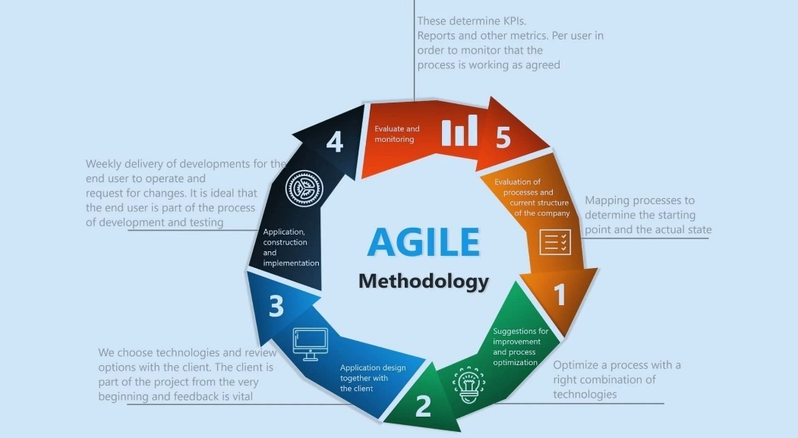

1. Research Design

The design methodology is for this project which leverages both power BI and Jupyter notebook to provide a comprehensive, data-driven approach to system analysis, development, and visualization. The process began with collecting and preparing data from various sources such as relational databases, CSV files, and APIs, which were then cleaned and preprocessed in Jupyter notebook using python libraries like pandas and NumPy. Exploratory data analysis (EDA) was performed in jupyter to uncover trends, correlations, and anomalies, enabling deeper understanding of system behavior and guiding feature development.

This study used a qualitative methodology to collect the data and resources needed to comprehend people's experiences with health services. This study sets out to assess several interfaces from the viewpoint of those with low literacy levels. As a result, our target subjects were neither properly educated (beyond the intermediate schooling level) nor completely illiterate (unable to read or write).

1. Design and Implementation:

The design and implementation of this project followed a structured and data-driven approach, integrating both Jupyter Notebook and Power BI for analysis, visualization, and decision support. The design phase began with comprehensive requirement gathering to identify system objectives and data needs, followed by conceptual modeling through diagrams and flowcharts to outline system logic. Data was sourced from relevant repositories, cleaned, and preprocessed using Python in Jupyter Notebook, where exploration data analysis (EDA) and model prototyping were performed. The insights gained were used to inform key design decisions and system architecture, which followed a modular and scalable structure for ease of maintenance. (Big data-driven public health policy making: potential for the healthcare industry).

1. Testing/ Maintenance:

The testing and maintenance phase was critical to ensuring the reliability, accuracy, and long-term performance of the system. Testing began with unit testing to validate individual components, followed by integration testing to ensure seamless interaction between modules. After deployment, a structured maintenance plan was implemented, including routine system checks, database optimization, bug tracking, and regular updates based on user feedback. Logs and monitoring tools were used to detect and resolve issues proactively. (The use of Big Data Analytics in healthcare published 06 January 2022).

1. Collecting requirement information

Observation strategies will be used to collect information on the existing situation. The observation approach was used to collect first-hand knowledge and a list of all currently available online appointment booking apps for this study. Journals, textbooks, reports, to the media, and internal sources all have the necessary information. In addition to the giving the researcher theoretical and literature-based skills, to the secondary source of the data also to the made it simple to understand and assess the information gathered. Data that has already been collected by other individuals or groups for their own purposes may occasionally be used in planning, monitoring, and analysis.

1. Analysis of requirements

I was able to collect secondary data for the development and implementation of this system by closely examining and researching the needs, limitations, and requirements of the health sector at the time. With the new paradigm I've proposed, we can see the advantages of using an on-demand service to schedule timely meetings with specialists and receive care in a timely and orderly manner.

1. Ethical Considerations

The aim of ethical considerations is to guarantee that the safety and privacy of participants are never jeopardized. These ideas include informed consent, anonymity of study participants, confidentiality of information, and voluntary involvement. Respondents' rights were respected during the whole data collection procedure, and they were not coerced into taking part in the study. Every poll respondent's personal information was also kept confidential.

1. Software Requirement Specification:

The Software Requirements Specification (SRS) outlines the functional and non-functional requirements essential for the successful development and deployment of the system. The system must enable secure user authentication, provide role-based access to reports, and support data import/export capabilities in common formats such as CSV and Excel. Non-functional requirements include system scalability to accommodate increasing data volumes, high availability with minimal downtime, user-friendly interface design, and responsiveness across multiple devices. (international journal of Health Science vol. 7,).

**Product Design**

1. Introduction

Product creation has been significantly and broadly impacted by digitalization. Smartphones and smart devices are among the many digital items that have emerged because of new business strategies. The massive volumes of data produced by these digital devices can be gathered and analyzed for design purposes. How can designers analyze the increasing volume of data in a methodical way to arrive at wise choices? This is the primary question that encapsulates the impact of digitalization on product design. (Ang Liu developed computer-driven design in 2024, combining data science and commercial design.)

This is a proposal for an online application that enables patients to schedule appointments with medical professionals. The model was described using modeling language. A design model, often known as a diagrammatic method, is an object-based representation of the system. Modeling helps a successful software company achieve all of the system's criteria since it simplifies the management of the many distinct object representations, activities, and system implementations.

1. Project Planning

In the healthcare industry, which is undergoing digital transformation, data science and analytics are being utilized to plan for the crucial role of patient care mapping and to optimize marketing tactics that make use of machine learning, artificial intelligence, and predictive analytics. This can help the company detect new diseases, customize patient care, and improve therapy. In this industry, agile, data-driven project planning that considers ethical and legal compliance is essential.

Regardless of the technology, project planning guarantees timely delivery and effective completion. A business that pursues excellence has a better chance of drawing in additional capital because of its satisfied customers. A successful project requires adherence to specific planning procedures. In this instance, the project is planned to use a Gantt chart, task sheet, and schedule.

1. Gantt chart

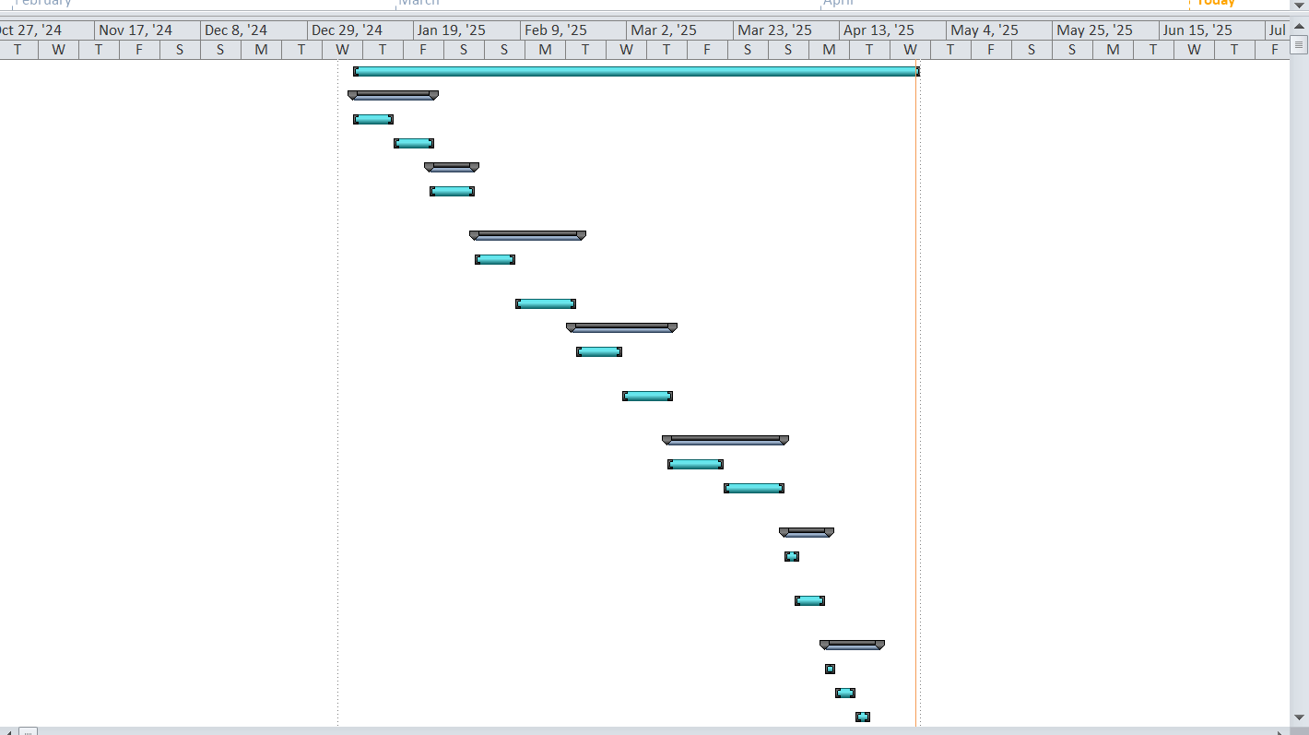

1. Task sheet

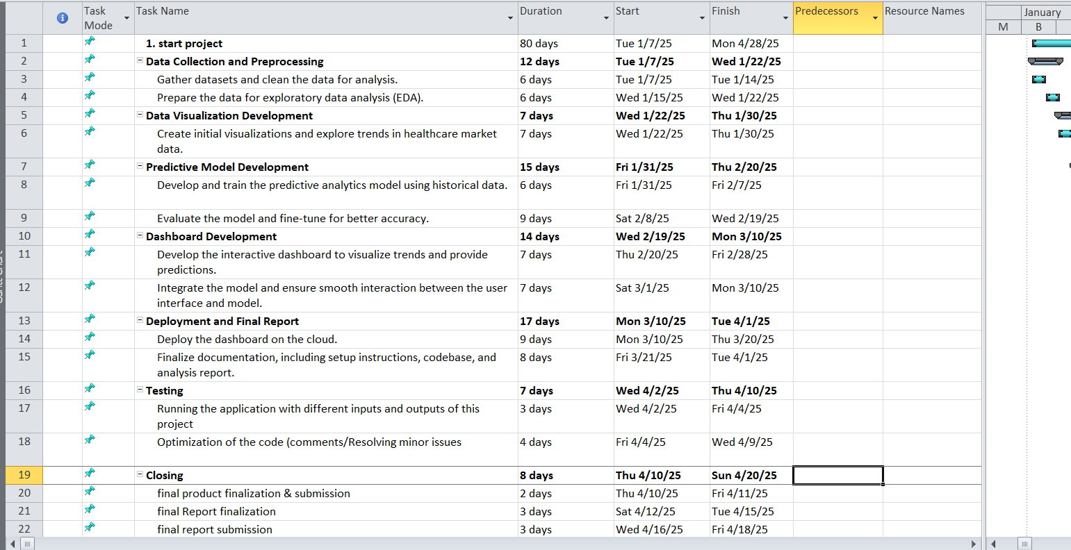

1. Timeline

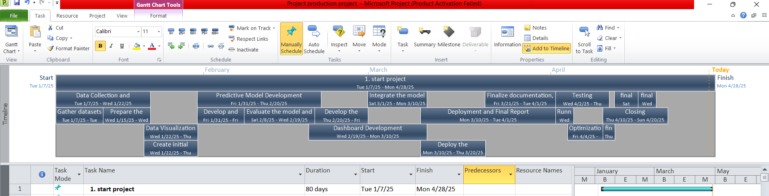

1. **Use case**

Analytics and data science are used in medical technology to predict market trends and enhance patient care. Predicting treatment trends, identifying new healthcare needs, assisting healthcare professionals in making strategic decisions, and creating analytics to assist businesses in anticipating shifts in patient demands are the main uses of these technologies. technology that affects whether a policy is accepted. Healthcare companies can enhance their operational performance by employing data analytics efficiently, according to Mckinsey & Company (2023).

One of the most difficult parts of software development is figuring out the project's objectives. Explain the interactions between different users, who may be people or other systems. A UML case diagram is meant to make system communication easier. Visual aids that show how users interact with a system are called case diagrams. These diagrams are used to determine and evaluate a system's demands.

There are four sections to use case diagrams.   
• Actor: An actor in a use case diagram is any entity that is a part of a single system. This could be an external system, a company, or an individual.   
• System: A rectangle that symbolizes the system defines the use of the case's parameters. The modeling of complex systems is made easier by this optional feature.   
• Use case: A use case is an illustration of how a system works or accomplishes an objective. It is oval and bears a label explaining its use.   
• Relationship: A relationship line shows the relationship between the use case and the actor.

**A case diagram for a healthcare dashboard**

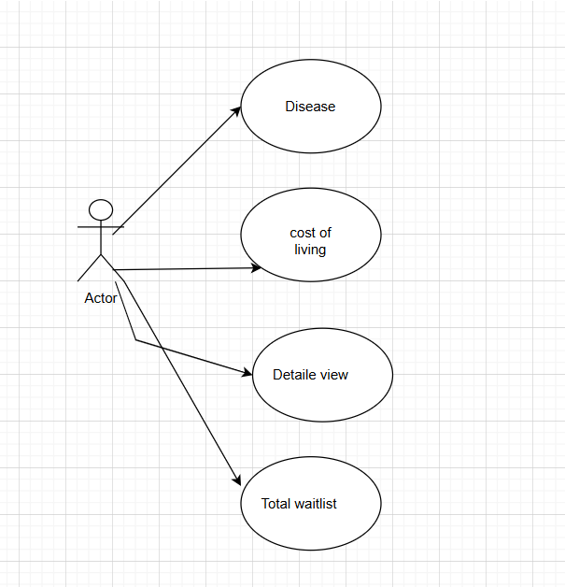

**Use Case Diagram for a Hospital Dashboard**

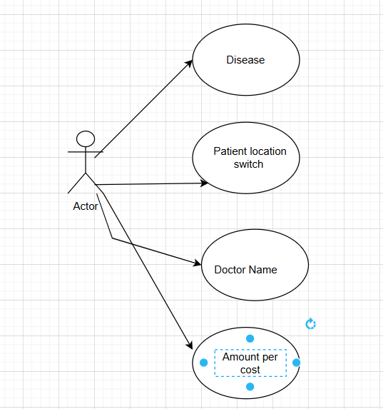

**The use case diagram for the administrator**

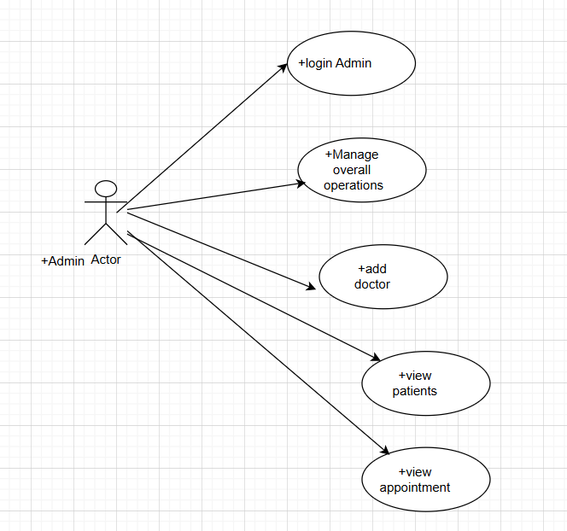

**The use case diagram for the patient**

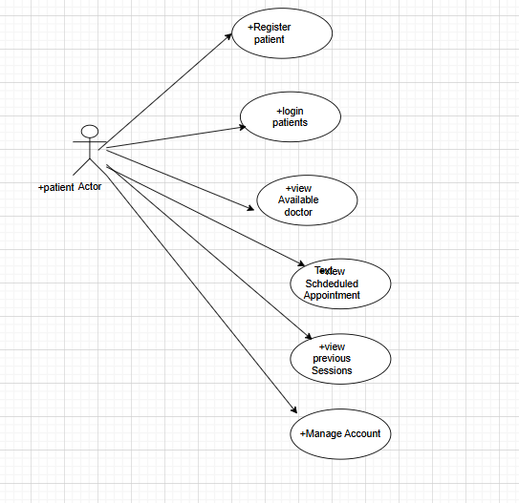

**The use case diagram for the doctor**

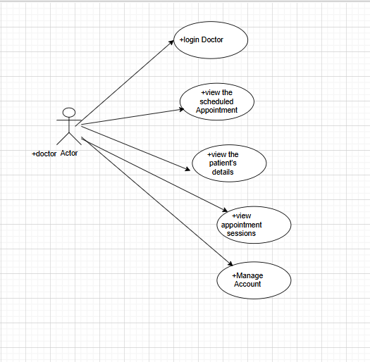

|  |  |  |  |
| --- | --- | --- | --- |
| **Use Case** | **Description** | **<<include>>** | **<<extend>>** |
| Login | To utilize all this app's capabilities, users must log in. | Authentication: Every time a user tries to access the program; they must verify their login information. | Registration: If a user does not already have an account, they can create one. |
| Register | Those who want to establish an account must first register. | Before the account may be activated, the user must be genuine. |  |
| Book  appointments | The user could arrange appointments. | Login: Prior to scheduling an appointment, the user needs to log into their account. |  |
| Dashboard | All users, including administrators, doctors, and patients, can access dashboards. | Activity: The dashboard's feature lets users keep an eye on their activities. |  |
| Settings | Each user would be able to change the profile linked to their account. | Update information: Customers can update their information by changing the settings. |  |

1. Control Flow Diagram

The data science stage, which employs analytics for project planning, procedures, and market trend monitoring, necessitates the usage of the flowcharts. For the project development and evaluation. By ensuring that the project is to the stakeholder and that of the data pipeline and data gathering of actionable insights are easy to understand, a well-structured flowchart also encourages transparency of the efficient project execution. IBM (2022) claims that the use of visual aids such as flowcharts in the data science initiatives improves the cooperation of specialists and technical teams.

The logical steps or phases that make up of the system or process are depicted in a control flowchart (CFD). Input and output are represented by parallelograms, to the decision points by diamonds, activities or processes by rectangles, beginning and ending points by circles, and branching or convergence by connections. By following the process through to the end of the stakeholders can understand the sequential sequence of events, including the decision-making points when the process due to deviates due to specific circumstances.

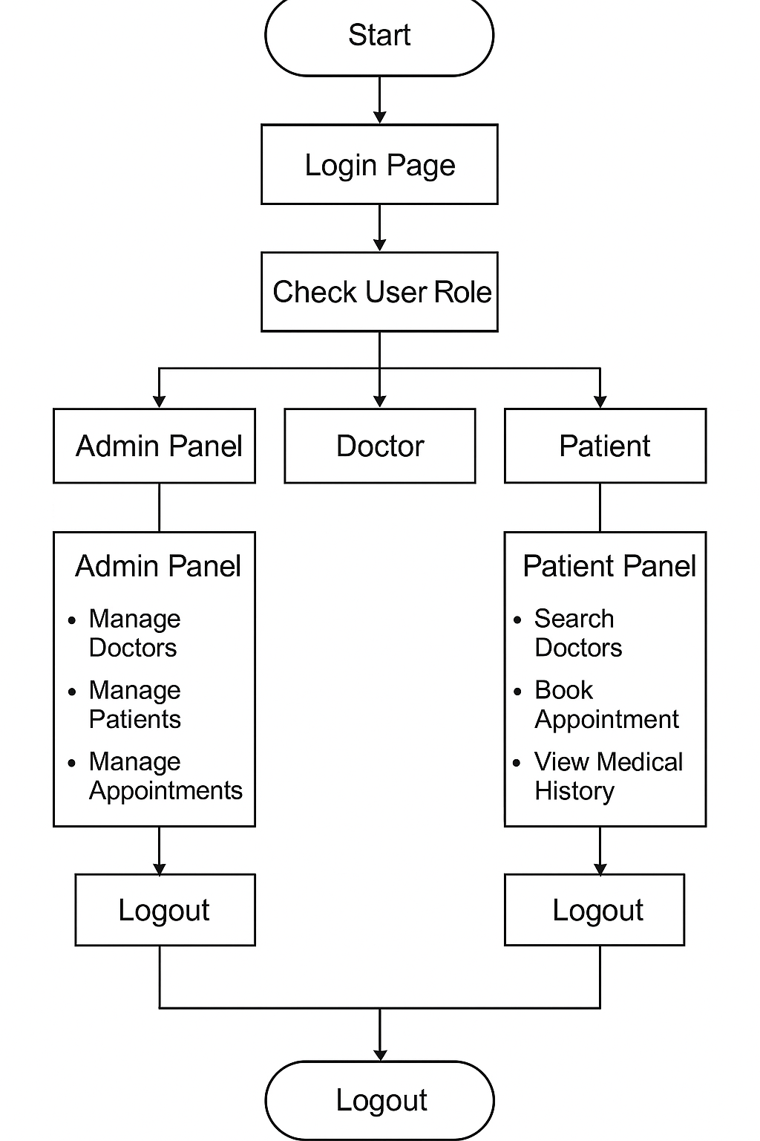

Fig: -The Flowchart for Healthcare

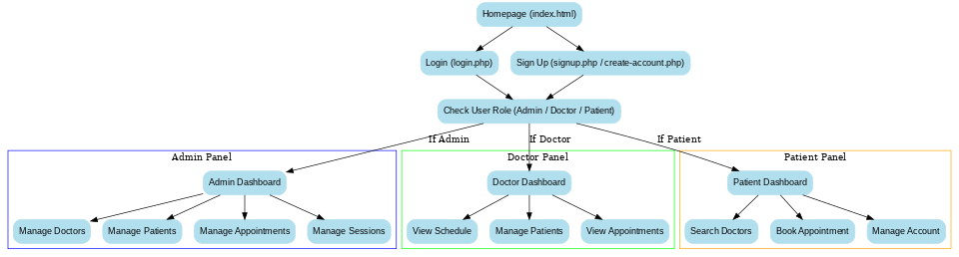

Fig: - The flowchart of the web application

1. ERD

The relationship diagram entity is the crucial part of the technology used to the arrange and display the medical data for to the analytics of this project. Erd facilitates communication between medical records, healthcare providers, and patients. Because properly utilizing ERDs guarantees sound data management, improves data quality, and facilitates adherence to the privacy regulations of the Oracle (2021) claims that by offering a transparent, to the scalable architecture for the handling enormous volumes of healthcare data, a clear ERD can enhance decision-making and lower database design errors.

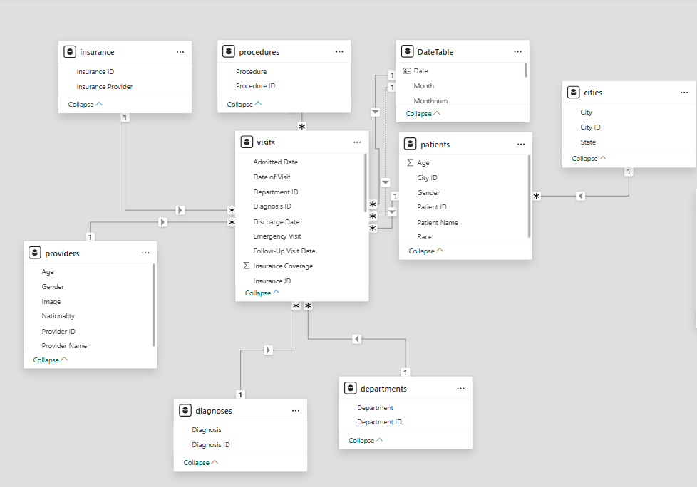

Fig:- The healthcare system's Erd diagram

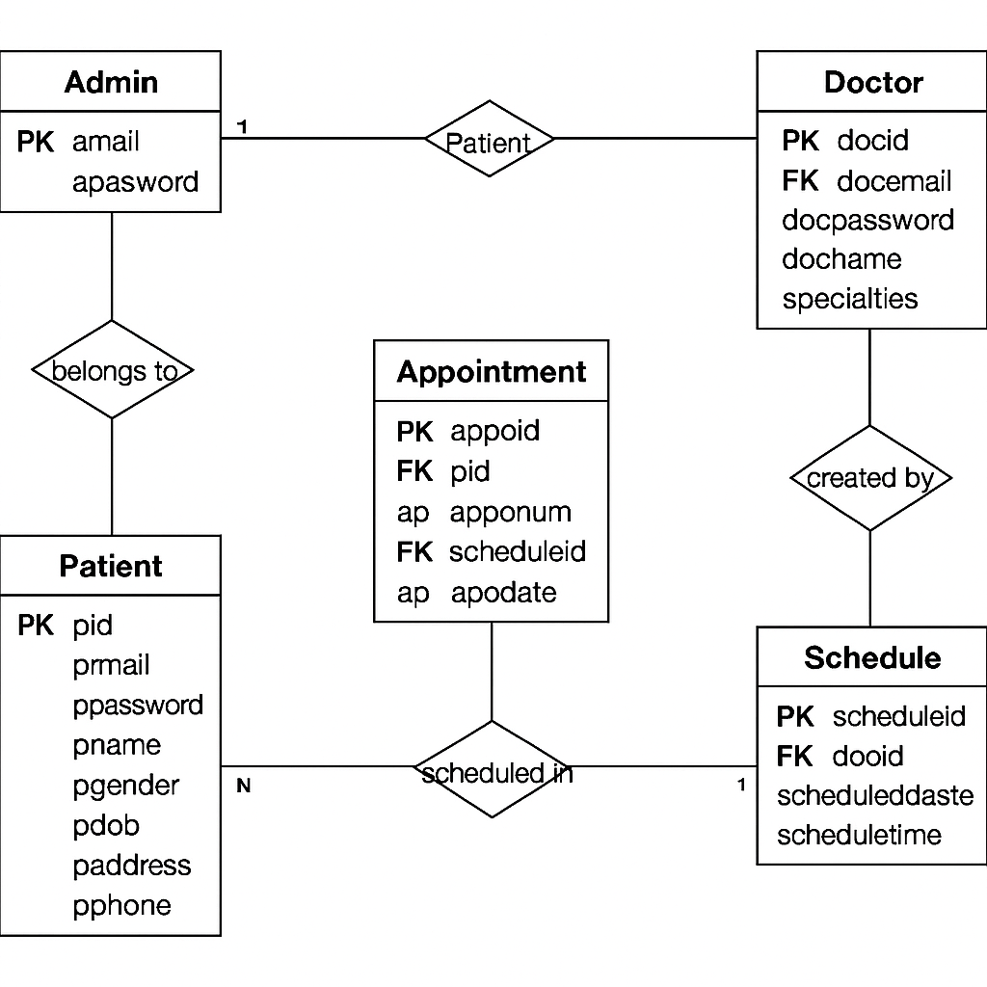

Fig:- The Web application system's Erd diagram

1. Wireframe Design

The wireframe is one of the most crucial tools for designing the data layout and the structure of the dashboard or data-driven healthcare application. According to Adobe (2023), the project wireframe expedites project development and facilitates early usability detection by improving early communication between developers, data scientists, and healthcare stakeholders.

An overview of any web or Android application is called a wireframe. Before the project begins, a wireframe is created to provide the idea of how the tasks should be completed to fulfill the project's deadlines.

**screenshots of the web application's wireframe for the health and healthcare dashboard**

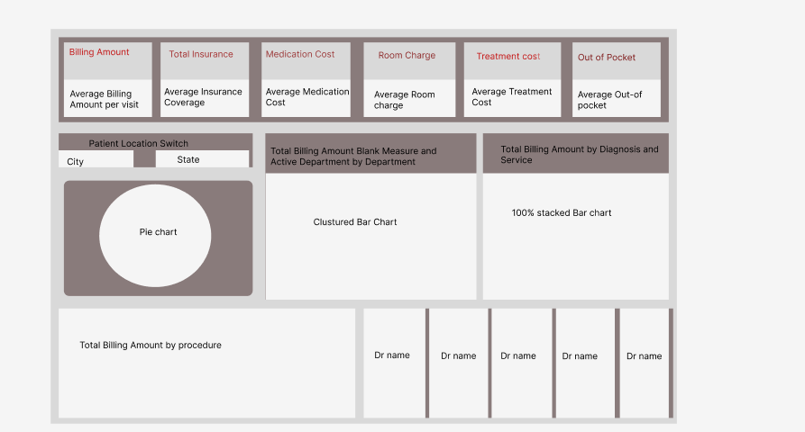

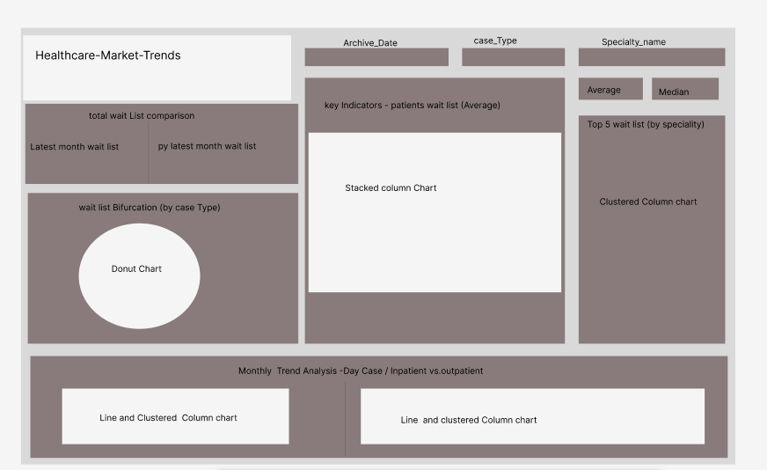

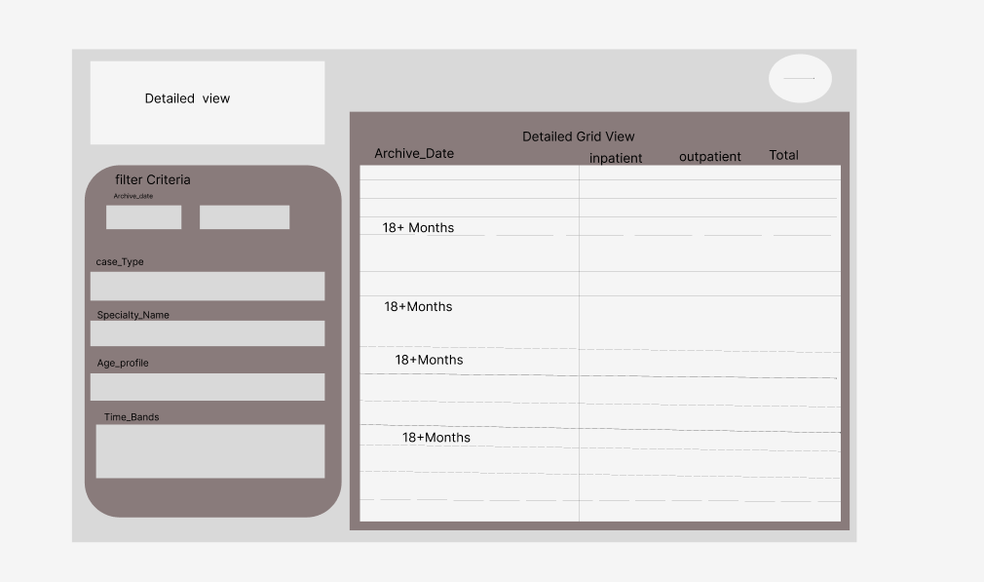

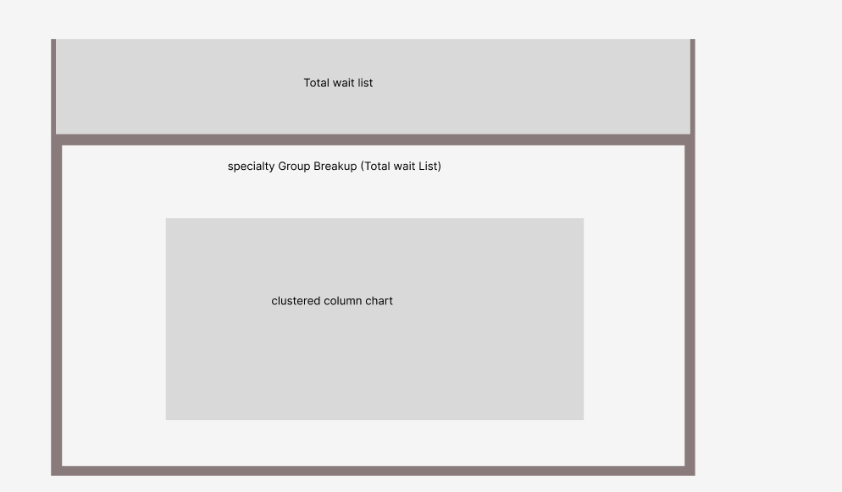

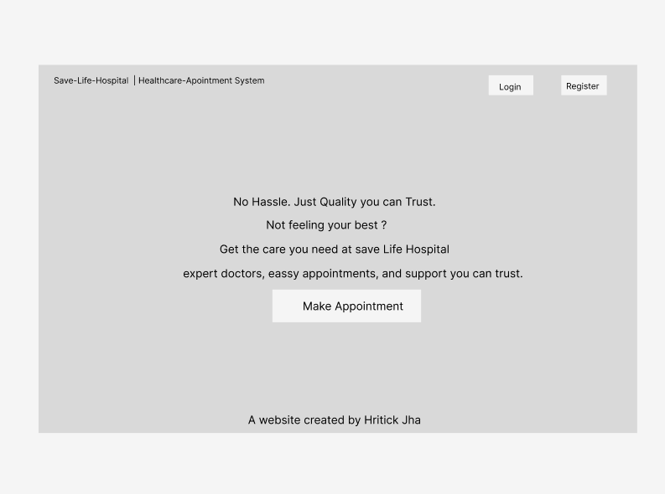

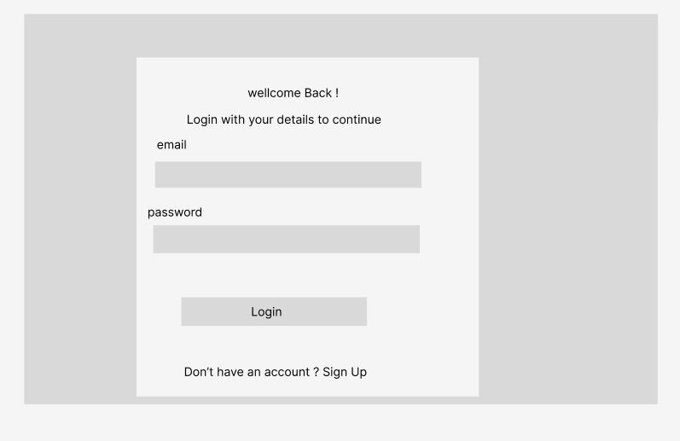

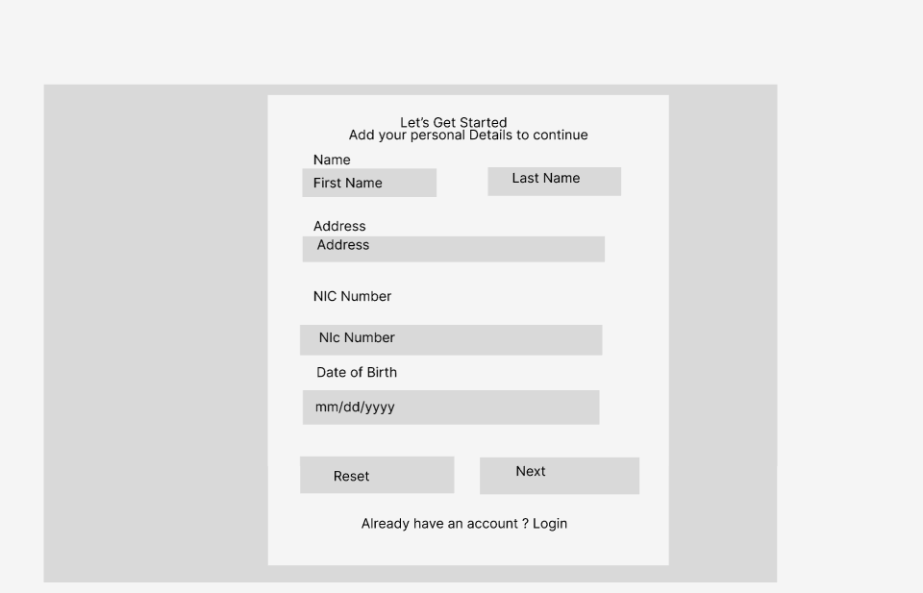

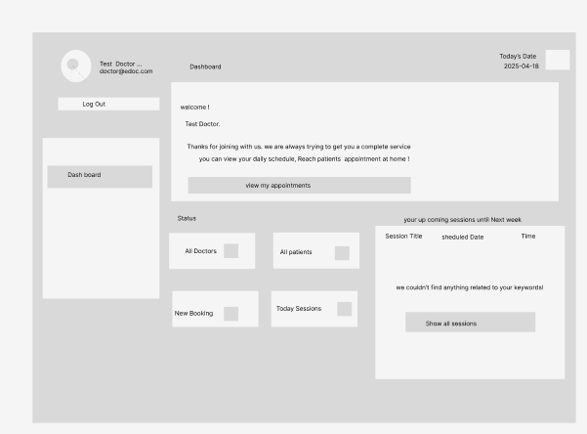

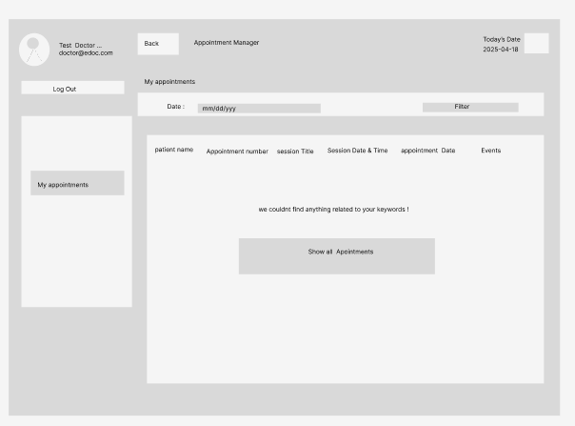

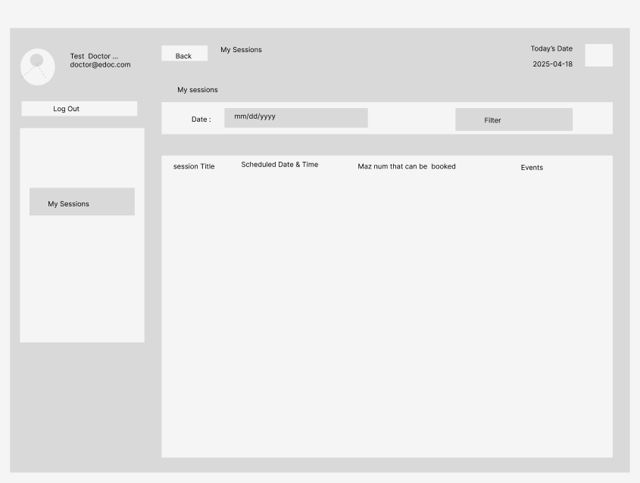

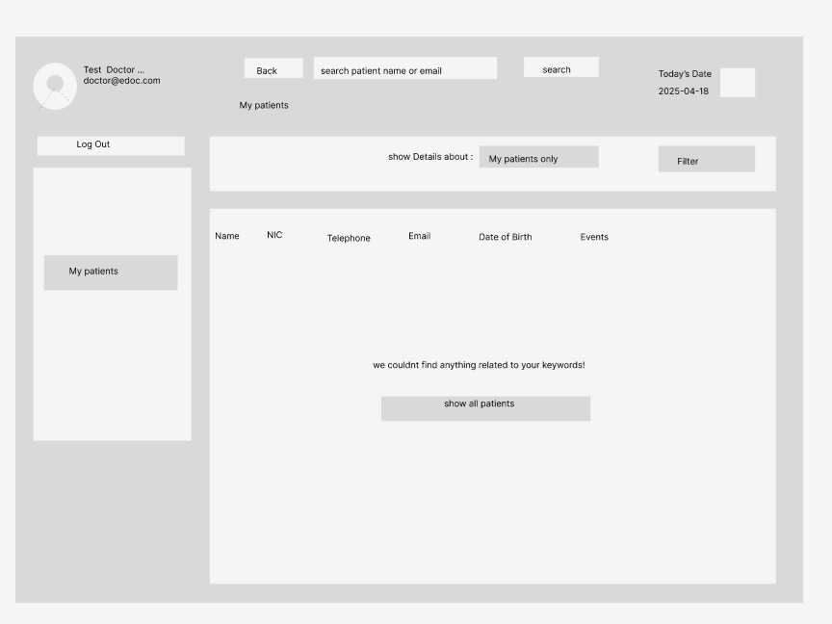

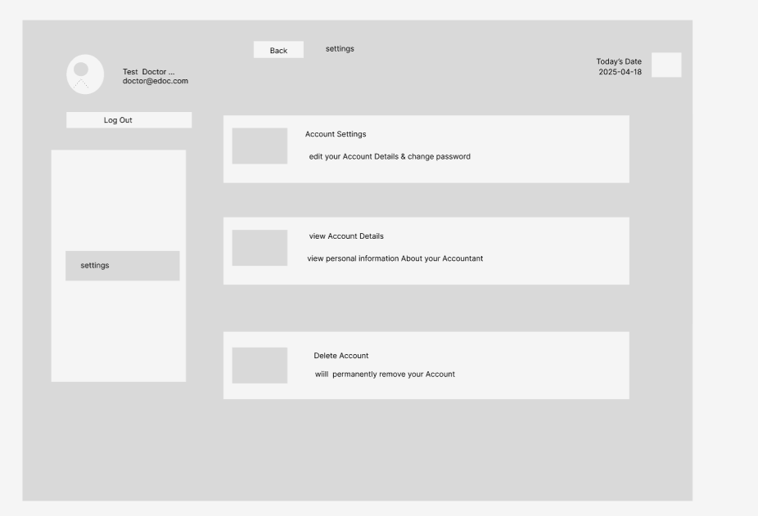

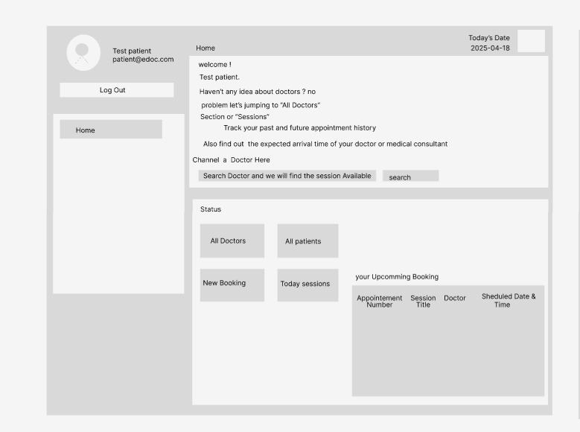

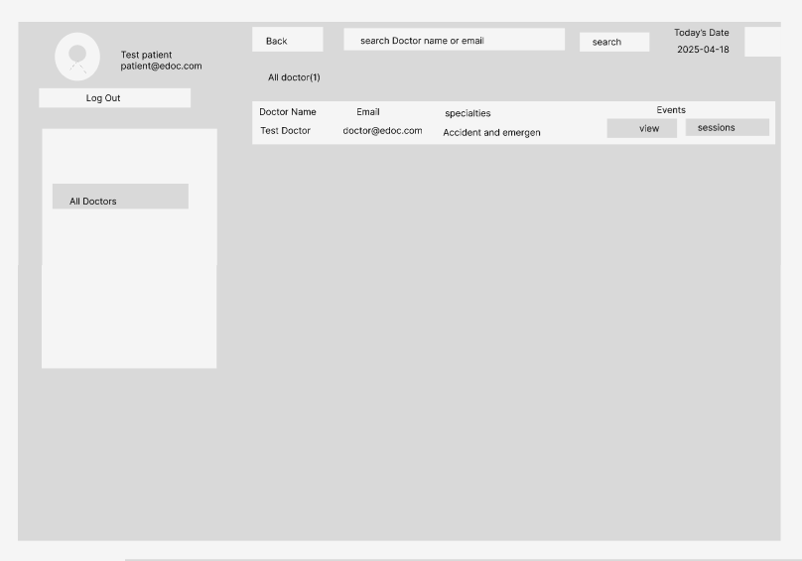

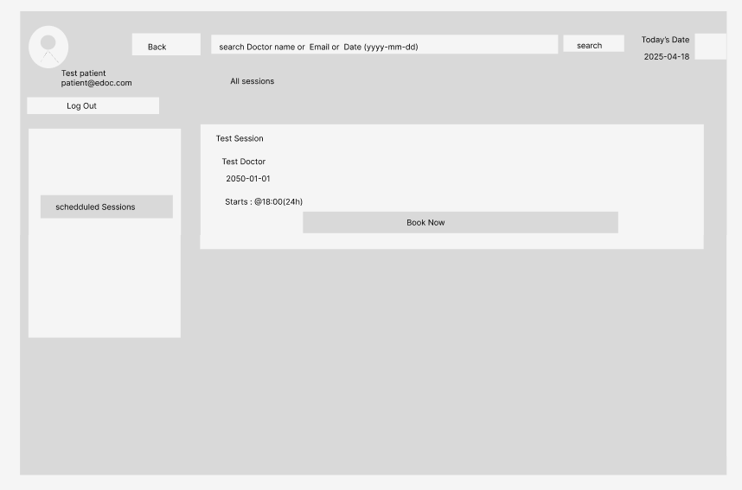

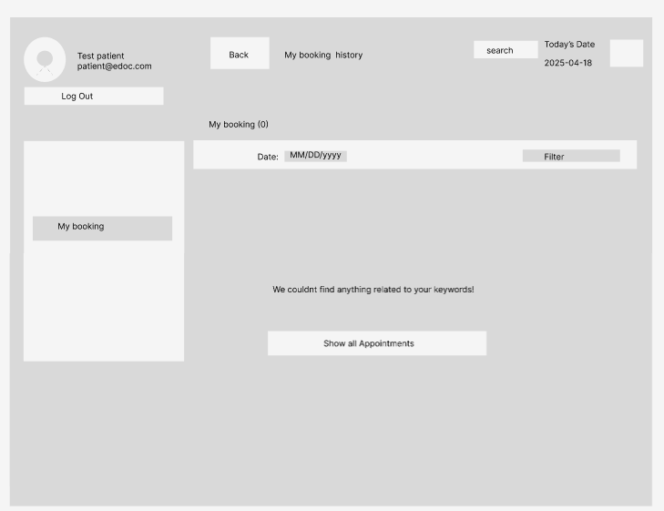

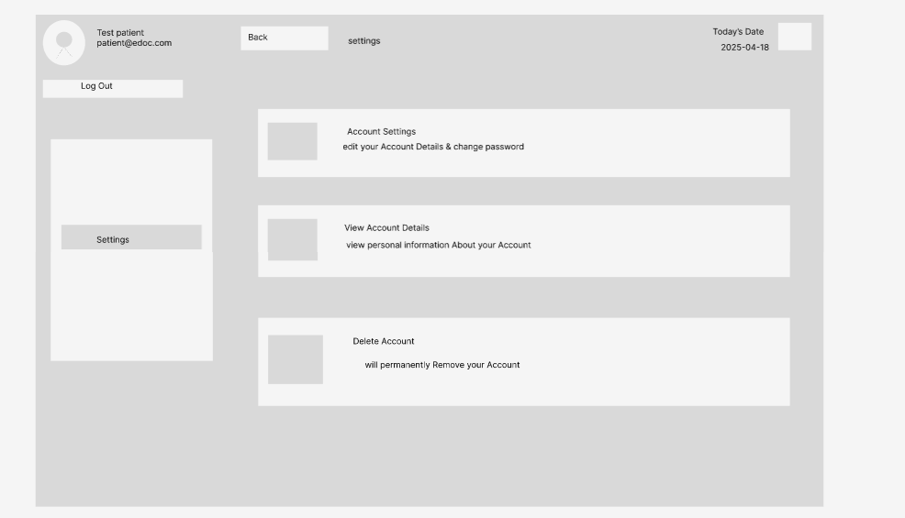

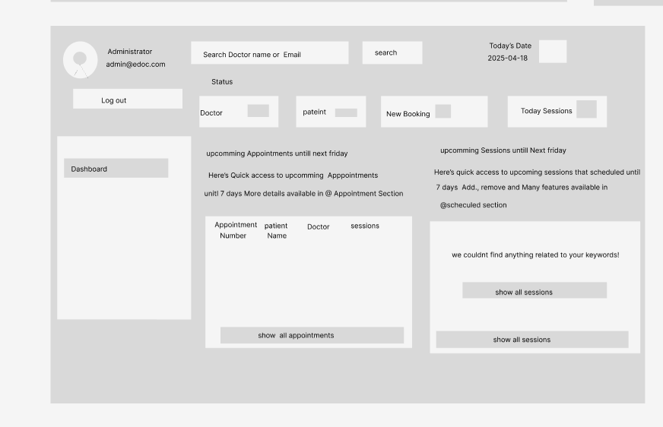

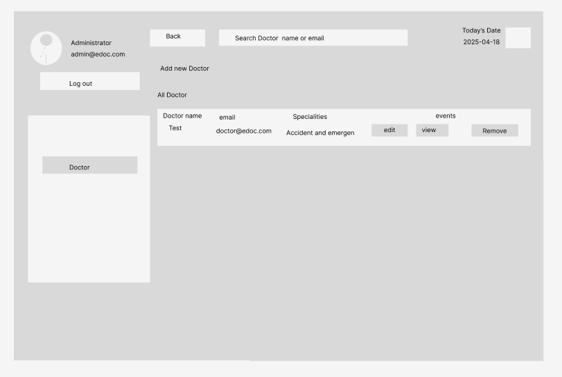

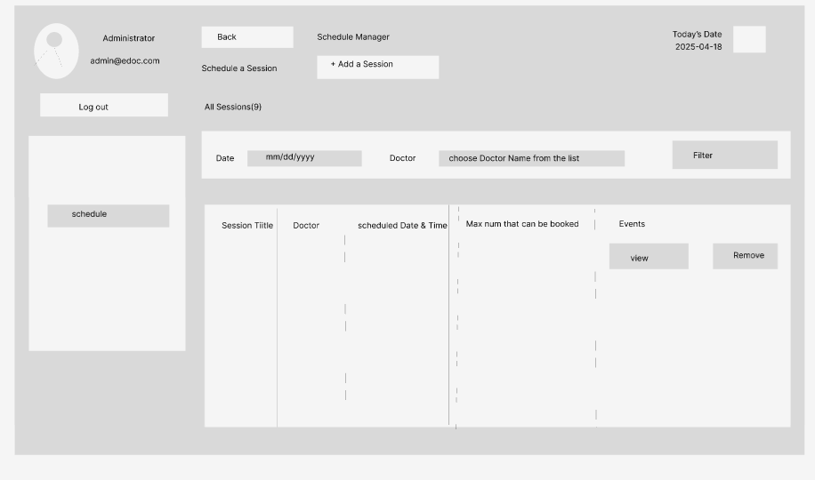

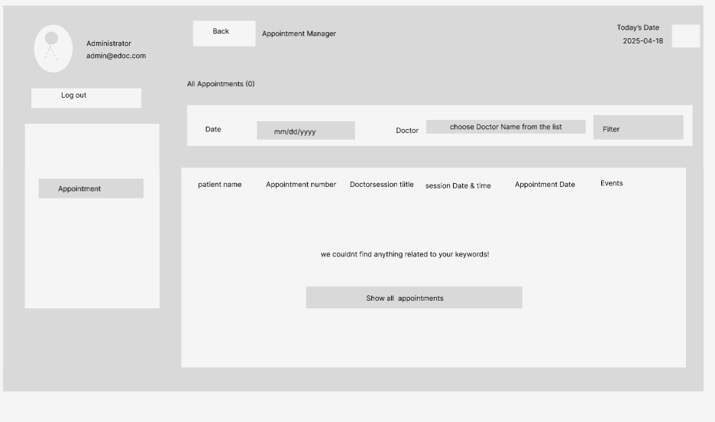

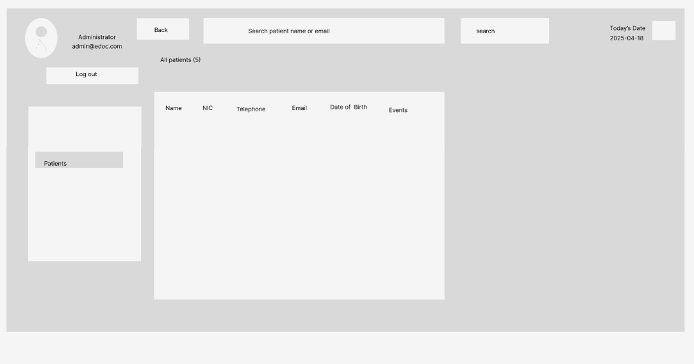

**Software Requirements Analysis**

A crucial phase in the healthcare data science projects is software requirement analysis, which the part of the guarantees that the functional and non-functional requirements of the system are precisely identified prior to the implementation. The final research satisfies user expectations for the tracking advancements in the healthcare industry while lowering development costs and hazards. According to Sommerville (2016), a comprehensive requirement to the engineering strategy is essential for healthcare projects to guarantee data accuracy, to take complexity into consideration, and facilitate system scalability and maintainability.

The software requirements outline the characteristics and features of the target system. The desires of the client may be known or unknown, obvious or hidden, expected or unexpected. The following software technologies are being used in the development of this project:

1. **Jupyter notebook**
2. **Vs code (visual studio code)**
3. **php, Html, CSS, JavaScript, python, Bootstrap, Xml**
4. **Apache server**
5. **Microsoft word**
6. **Microsoft Power BI**
7. **Microsoft power point**
8. **Microsoft project**
9. **Microsoft Excel**
10. **Draw.io**
11. **Figma**
12. **Web browser**
13. **Jupyter Notebook**

Jupyter Notebooks are frequently utilized in the data science projects in the medical field because to its capacity to the integrate text, equations, live code, and photos into the single interactive document. They offer of the flexible environment for evaluating healthcare data, developing predictive models, spotting trends, documenting to the entire process in a shareable format, utilizing a Jupyter Notebook to the document the healthcare analytics process, and strengthening collaboration among data scientists, clinicians, and stakeholders to the generate clear and repeatable results.Jupyter notebooks are the currently the mainstay of the scientific computing toolkit, supporting the open-documentation approach to data analysis and facilitating data exploration (Klumyver et al., 2016).

1. **Vs code (visual Studio Code)**

The lightweight and powerful code editorto the Visual Studio Code (VS Code) is thefavorite among data scientists and developers working on the healthcare and analytics projects. Additionally, it makes extension-based code quality adjustment possible, which boosts output, cooperation, version control, and the efficiency of the real-time coding. to the broad ecosystem of extensions and integrated debugging of the capabilities make Visual Studio Code the best option for developing, testing, and implementing data-driven, healthcare, and analytics solutions, according to Microsoft (2023).

To satisfy the demands of the contemporary software engineers, Microsoft created Visual Studio Code (VS Code), a strong and adaptable source code editor. By allowing developers to the customize the editor to the fit their own project needs and workflow, a strong ecosystem of the add-ons found in the Visual Studio Code to the Marketplace can further increase of the editor's functionality. In the software development environment, the Visual Studio Code (VS Code) is the crucial tool that speeds up the writing, debugging, and release of code. Its active community, regular updates, and user-friendly design make it a vital tool.

* **Php**

The popular open-source scripting language PHP, or Hypertext Preprocessor, is used to create webpages. PHP is an HTML embedding that makes it possible to create dynamic webpages and communicate with databases. The first time Rasmus Lerdorf achieved success was in 1994. PHP is compatible with several databases, including MySQL, and functions well with HTML, CSS, and JavaScript. Known for its versatility and ease of use, PHP is the foundation of many well-known websites and content management systems, such as WordPress.

* **Html**

Web content is created and arranged using HTML, a markup language. This is the language in use. It describes how the text, pictures, links, and other multimedia components that make up a webpage are arranged. Together with JavaScript and CSS, HTML provides a web page's structure.

* **CSS**

The way that HTML displays and arranges text is described by the style sheet language called CSS (Cascading Style Sheets). To differentiate content from design and more efficiently generate information for the internet, it controls the colors, typefaces, spacing, and layout of web pages.

* **JavaScript**

JavaScript is a dynamic, high-level programming language used to create dynamic, interactive web content. It is possible to enhance functionality and user experience by utilizing advanced features like form validation, animations, and real-time changes.

* **Python**

Python is the most widely used programming language for analytics and data analysis in the healthcare sector because of its robust libraries, including pandas, NumPy, Scikit Learn, TensorFlow, and matplotlib, as well as its ease of use and readability. Python is the greatest tool for analysis since it speeds up the machine learning, sophisticated models, data pipelines, and visualization. Van Rossum and Drake (2009) assert that Python is a leading language for scientific computing and healthcare innovation because of its simple syntax and strong, community-driven development.

* **Bootstrap**

Bootstrap is the popular open-source framework for the building of mobile-first, flexible websites. It expedites to the process of creating aesthetically pleasing and functional websites by utilizing pre-made HTML, CSS, and JavaScript elements such as buttons, forms, and navigation bars.

* **.xml**

XML stands for extensible markup, which simplifies data storage and manipulation. Words. To improve data flow between various systems and applications, it describes a set of guidelines for encoding messages in a way that is understandable by both computers and humans. and gadgets.

1. **Apache server**

The Apache Software Foundation developed the powerful open-source web server software known as Apache Server, or Apache HTTP Server. Because of its many features, stability, and versatility, it was one of the most popular web servers at the time. It first appeared in 1995 because of its many features, which are supported by modules. It is compatible with a wide range of operating systems, including Windows, Linux, and Unix. Apache is the main technology used to create and host websites. It has a robust community support system and can provide both static and dynamic content.

1. **Microsoft word**

Microsoft created Word, a powerful word processing application that is commonly referred to as Word. When Word was initially made available on October 25, 1983, it was compatible with Xenia systems. It became available for Macintosh in 1985. Following its 1989 release, Word for Windows gained widespread recognition right away. Two significant Word improvements are the Ribbon interface, which in version 2007 replaced traditional menus with an easier-to-use tabbed structure, and the Reading structural view, which in version 2003 enhanced interoperability with XML.

1. **Microsoft power BI**

Users can visualize healthcare data, that observe market trends, and share insightful information with colleagues in their organizations of using the Microsoft Power BI. Analysts and medical professionals can create interactive dashboards and reports that support strategic planning and decision-making by utilizing a range of data sources. According to Microsoft (2023), Power BI benefits companies by providing better insights through advanced data modeling, AI capabilities, and seamless teamwork.

1. **Microsoft power Point**

One of the greatest resources for educating a large audience about intricate healthcare data analytics and the industry trends is Microsoft PowerPoint. Infographics, charts, graphs, and well-organized slide layouts are just a few of the visual elements that the data scientists and medical professionals can use to effectively convey their findings. Microsoft (2023) asserts that PowerPoint is a vital tool for efficient communication due to its user-friendly graphics, animations, and collaborative features, all of which improve data storytelling.

1. **Microsoft project**

Data science and analytics initiatives on the healthcare industry can be the easily planned, scheduled, and overseen with the help of the Microsoft Project, a powerful project management tool. Gantt charts, kanban boards, and dashboards allow users to create tasks, assign resources, set deadlines, manage budgets, and track project progress. Microsoft (2023) claims that Microsoft Project enhances collaboration, makes the best use of available resources, and raises awareness of project risks and timelines, all of which contribute to better project outcomes.

1. **Microsoft Excel**

The most important tool for planning, evaluating, and visualizing data into the healthcare analytics projects is Microsoft Excel. It can be used to efficiently handle large datasets for statistical research, pivot table creation, and visual aid creation to identify trends and insights in the healthcare sector. These tools can help healthcare organizations make data-driven decisions, according to Microsoft (2023).

1. **Draw.io**

Draw.io, originally known as the diagrams.net, is the free online diagramming tool that for data science and healthcare analytics applications. Wireframes, ER diagrams, flowcharts, and other visual documentation are created with it. Diagrams.net (2023) claims that draw.io is a popular option for safe and collaborative diagramming in a variety of sectors, including healthcare, due to its interaction with programs like GitHub, Microsoft OneDrive, and Google Drive.

1. **Figma**

Figma is a well-liked cloud-based design to the prototype tool for the data science and healthcare analytics applications. It is used to build collaborative designs, dashboards, wireframes, and user interfaces. Figma is a great tool for creating interactive dashboards and mobile apps for healthcare applications that display market trends and patient data insights. Figma (2023) claims that because of its emphasis on accessibility, collaboration, and quick prototyping, it is a crucial tool for teams developing creative, data-driven solutions.

1. **Web Browser**

The program that enables users to access, retrieve, and view content on the World Wide Web is called the web browser. It comprehends and the displays HTML, CSS, JavaScript, and other web technologies so that the users can be the navigate webpages and web applications technologies. Popular web browsers include the Google Chrome, Microsoft Edge, Safari, and Mozilla Firefox. When utilizing the internet on a regular basis, web browsers are required. To access and utilize internet resources and services, they are required.

**Implementation and Testing**

**Implementation**

To produce the meaningful data during the implementation of the phase of the healthcare data science of the project, which analytically the models, of the dashboards, and the systems of the must be used in the real-world contexts. Among the duties involved in the implementation are data in integration, model deployment, and visualization setup (such as Power BI dashboards), and the guaranteeing adherence to the security and privacy regulations like HIPAA. According to Kelleher and Tierney (2018), the successful execution of data-driven projects requires cooperation between technical and healthcare teams.

The idea should be implemented using the current system and appropriate programming techniques. XML, PHP, and CSS were selected as the It has shown itself to be the reliable in the development of the web applications. Additionally, MYSQL was selected as the primary because it enables them to operate efficiently and concurrently.

**Database connection (MYSQL)**

A relational database is the management system is the MySQL. The reliability, of the scalability, and user-friendliness of the MySQL make it a well-liked and extensively used in the relational database management system. Using a variety of the SQL commands and the queries, MySQL, a product of the Oracle Corporation, and the enables you to handle and alter data. It is the ideal for web applications and online data storage due to its the powerful performance and multi-user access to the multiple databases. Because it integrates readily with programming languages like PHP and performs effectively on the range of the systems, MySQL is a popular choice among developers. Its robust security measures ensure data confidentiality and integrity, and its open-source nature allows for unlimited modification.

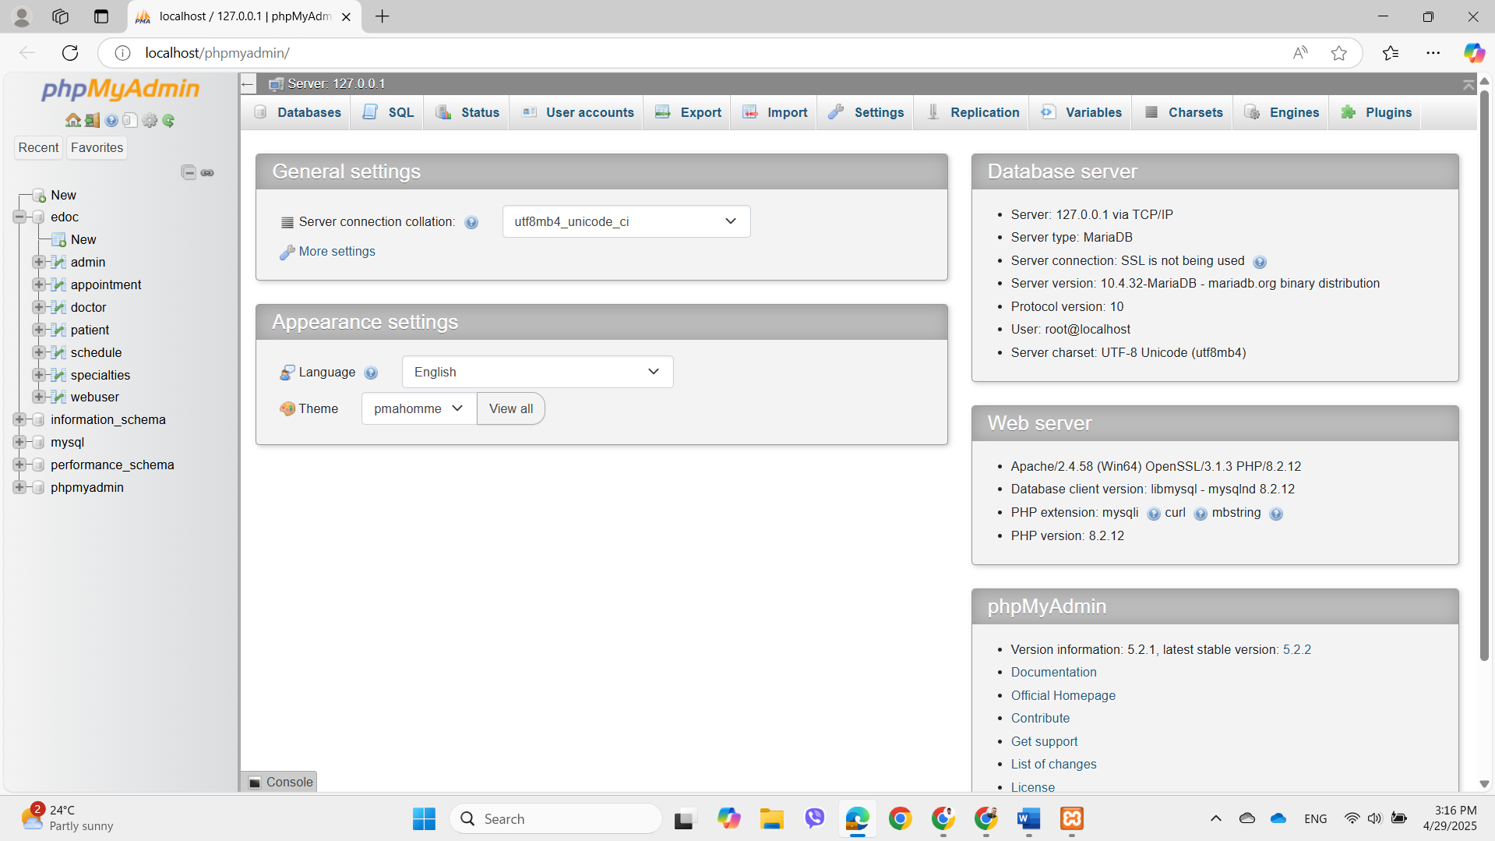

Fig: MySQL Database

**Implementing the layouts**

Layout implementation is the process of transforming wireframes and design mockups into the functional dashboard, report, or the online application of the user interfaces. This approach involves aligning visual components like tables, charts, filters, and maps with design systems and user experience (UX) concepts. Front-end technology (such as HTML, CSS, and JavaScript) and programs like Power BI and Figma give static designs alive. According to the Nielsen Norman Group (2023), in complicated situations like healthcare, well-executed layouts enhance usability, reduce cognitive strain, and improve data interpretation.

The process of combining many technologies to the give a web application's user interface structure, appearance, and functionality is the known as the layout implementation. Backend technologies that control data to the processing and transmission include server-side frameworks and database integration. While developers use the front-end frameworks like React.js to generate the layout, designers produce wireframes to show it.

**Testing**

Because it guarantees up the models, systems, and the visualizations work as to the intended, satisfy user the needs, and produce accurate the results, testing is the crucial phase in the data science and the analytics initiatives. According to the Provost and Fawcett (2013), extensive testing is required to maintain confidence in the data-driven systems, especially in sensitive domains like healthcare where accurate predictions or insights could have disastrous consequences.

Testing entails running code in a scenario-specific fashion, carefully going over the code, and assessing the code, system, unit, are the integration testing are just a few of the many testing methods available. During the beta phase, the system is tested by both programmers and users. Developers will test every system to the module and pattern using unit testing.

**Manual Testing**

The process of manually confirming that the dashboard or the healthcare analytics system functions as the expected up the absence of automated procedures is the known as manual testing. Data science tasks include evaluating user interfaces, verifying data input, making sure all features work as intended in both the expected and unforeseen situations, and assessing the caliber of the visualizations (such the tables and charts in Office BI). Manual testing is still an essential method for exploration, usability, and interface validation, especially in complicated fields like healthcare, claim Myers et al. (2011).

The process of evaluating an application's functionality in line with manual testing includes determining user requirements without the use of automated technology. A tester with a thorough understanding of the product may quickly create a test document by manually testing any software.

**Unit Testing**

Unit testing is the process of independently assessing distinctly the little parts (often referred to as "units") of the program or data system to ensure that each one the functions as the intended. In the healthcare data science initiatives, unit testing is frequently applied to data transformation methods, computation scripts, the model elements, and logic that produces reports. According to Freeman and Pryce (2010), unit testing promotes rewriting, improves code quality, and facilitates the safe integration of the new features into data-driven applications.

All the programs are the essential elements that passed the test. The Login function of the displayed error warnings if the invalid password or the unregistered email was the entered, even if access to the account was granted by the entering verified credentials. When the unregistered email address and the validated password were entered during the Sign-Up procedure, the system successfully generated the account and correctly verified the necessary information.

Users can see and read all account activity on the Dashboard. Accessing and navigating their prior appointments was likewise effortless for users. After choosing the Log Out option, the user was able to successfully log out of the account. Every test yielded a "pass," meaning that the main features of the system are operating as planned.

**Verification**

Verification is the process of ascertaining whether the system, model, or the analytical solution was the built precisely in compliance with the specifications and design the documentation. Verification in the healthcare data science ensures that the analytics pipeline, which comprises the data collection, preliminary processing, and visualization, operates on the schedule and conforms with the technical specifications. According to the Pressman and Maxim (2014), verification techniques are the including code reviews, walkthroughs, and test execution are the crucial for the spotting errors early on the and ensuring system dependability in sensitive industries like healthcare.

Every crucial stage of the Health Connect the web apps of the login, and the launch procedures were correctly verified. The completion of all the anticipated outcomes shows that the Health Connect web app's login and the fundamental user flow functionalities are running smoothly.

**Functionality Review**

**The main page and welcome page for the healthcare market trends and sickness dashboard**

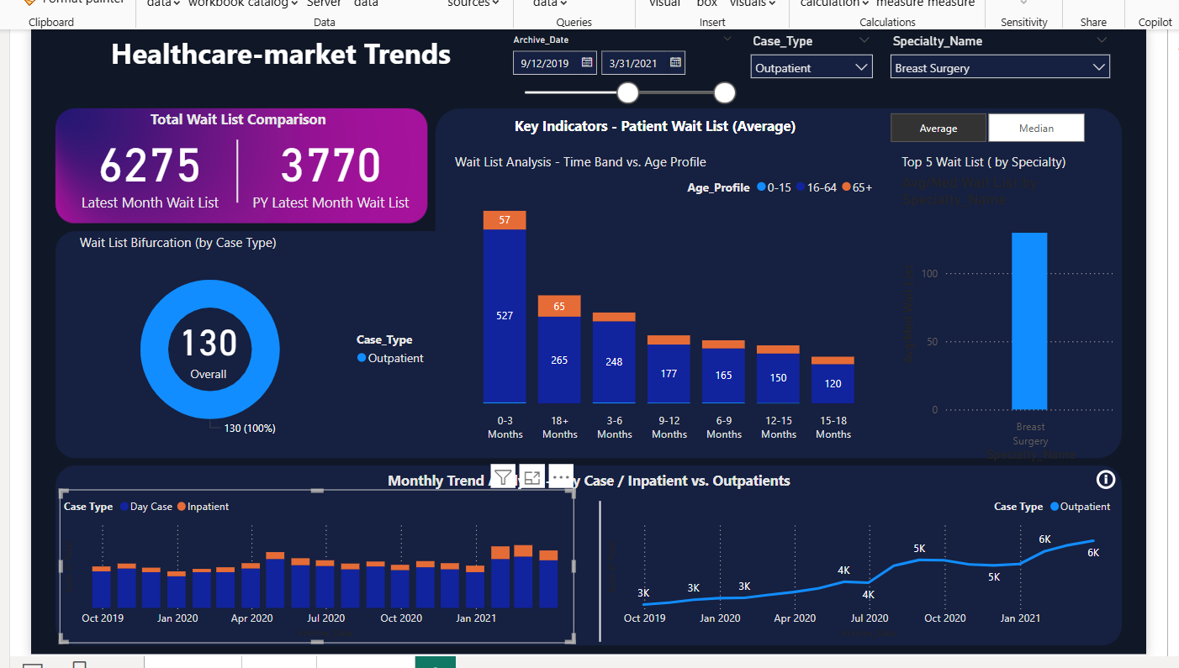

**The full dashboard's second page shows the healthcare market trends unique to the ailment.**

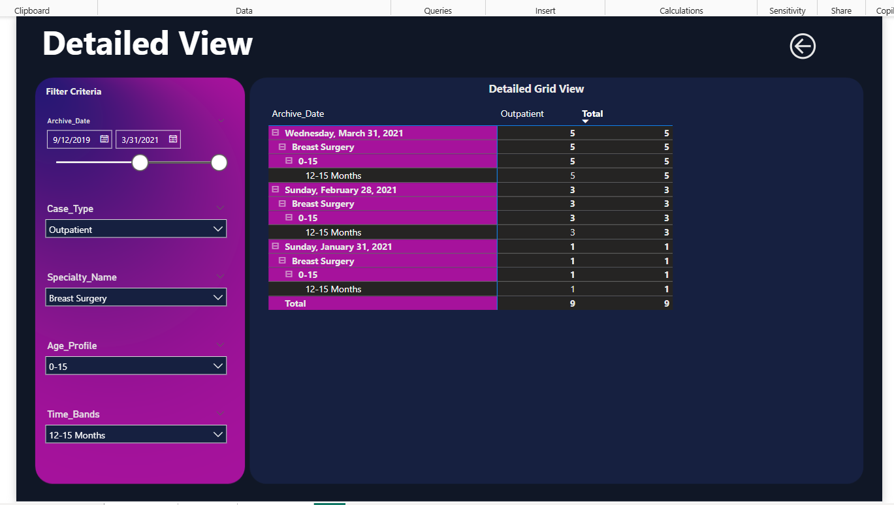

**The dashboard's third page shows the entire wait list for healthcare market developments.**

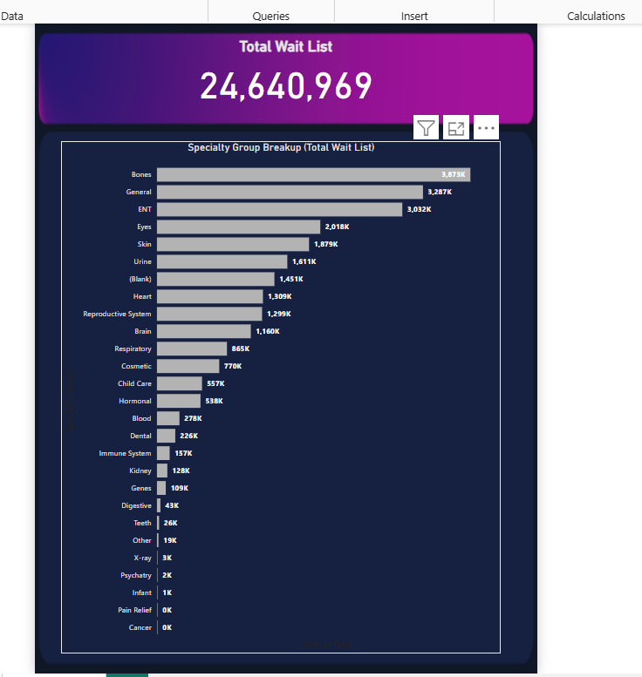

**The page and welcoming space for the healthcare industry's developments and documentation.**

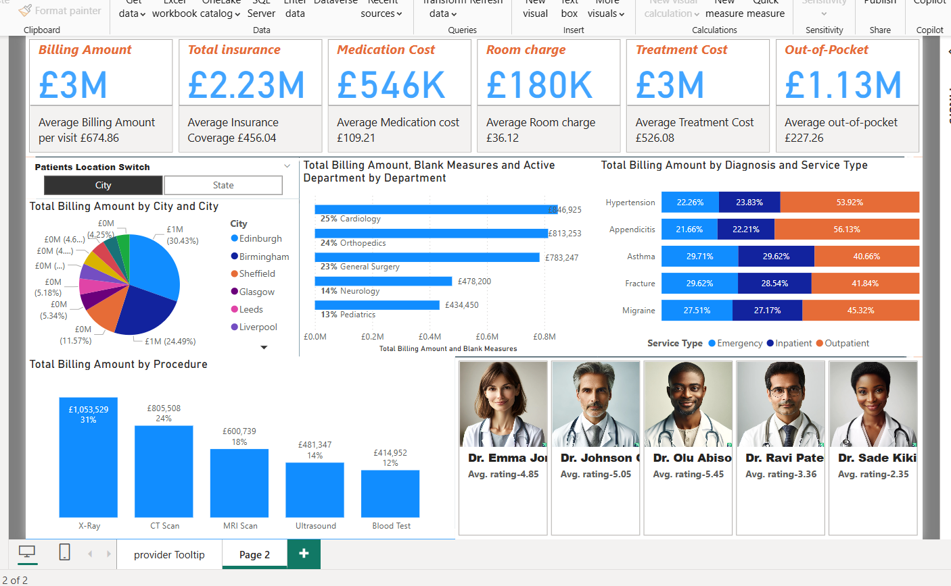

**The web application Trends in the healthcare market's home page or welcome page**

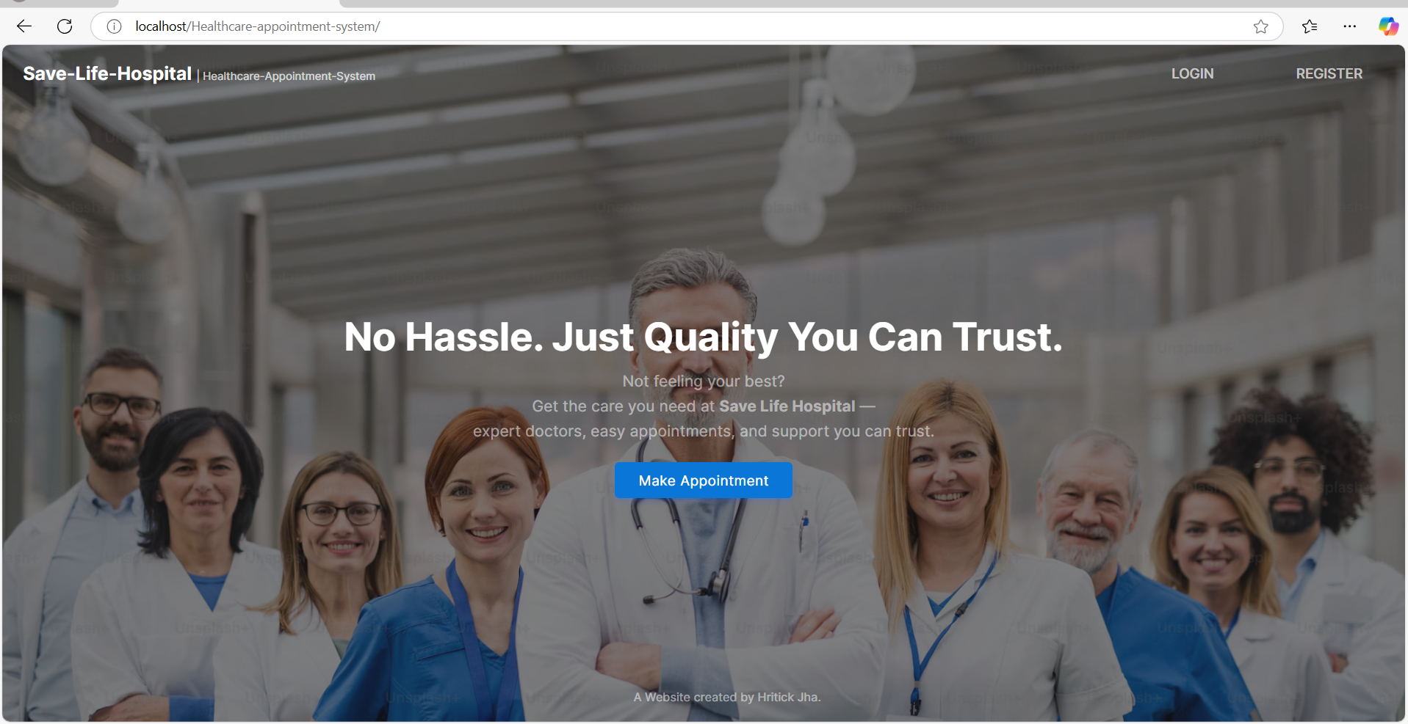

**Login page**

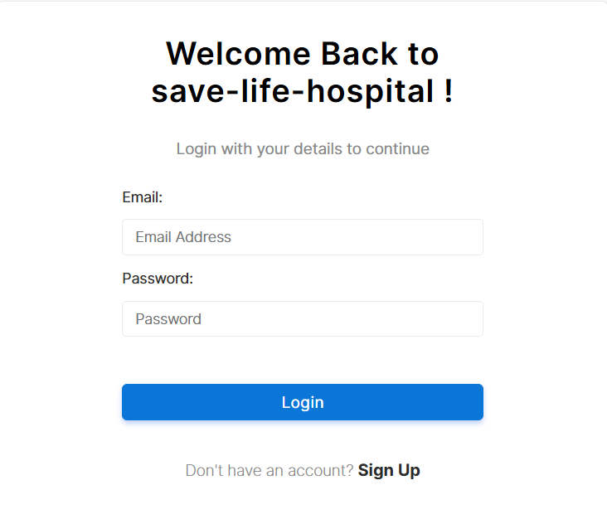

**Sign up page**

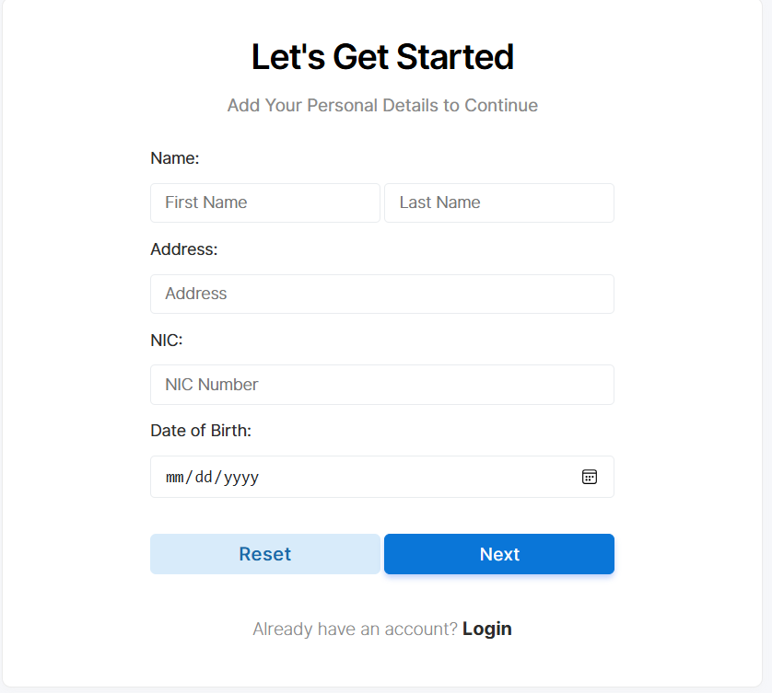

**Home page for patients**

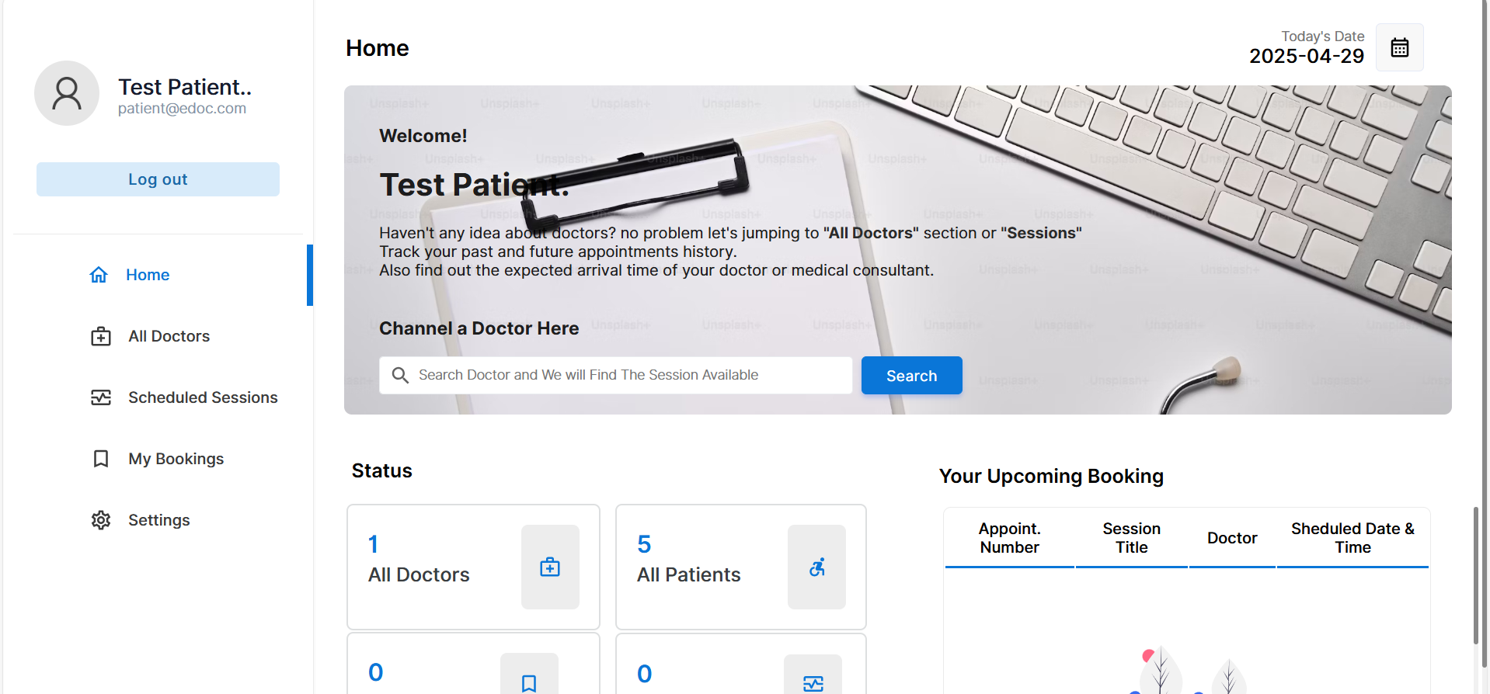

**Doctor list displayed in patient page**

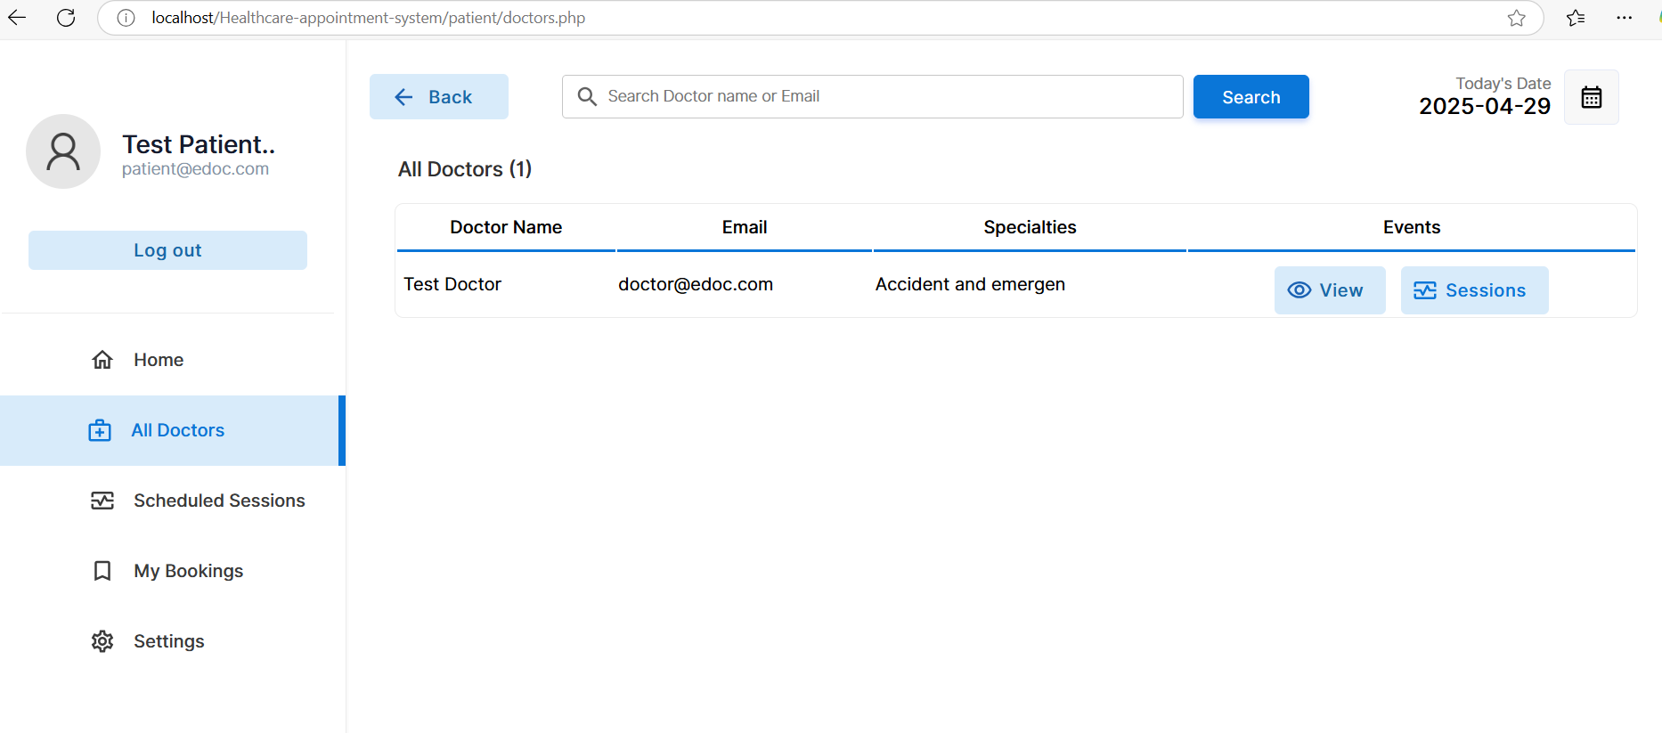

**Scheduled Sessions page for the patient**

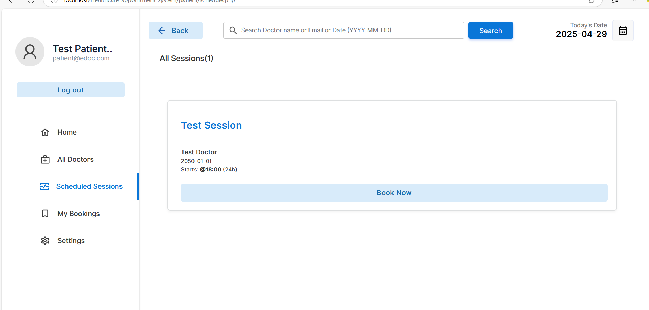

**Appointment booking section for the patient**

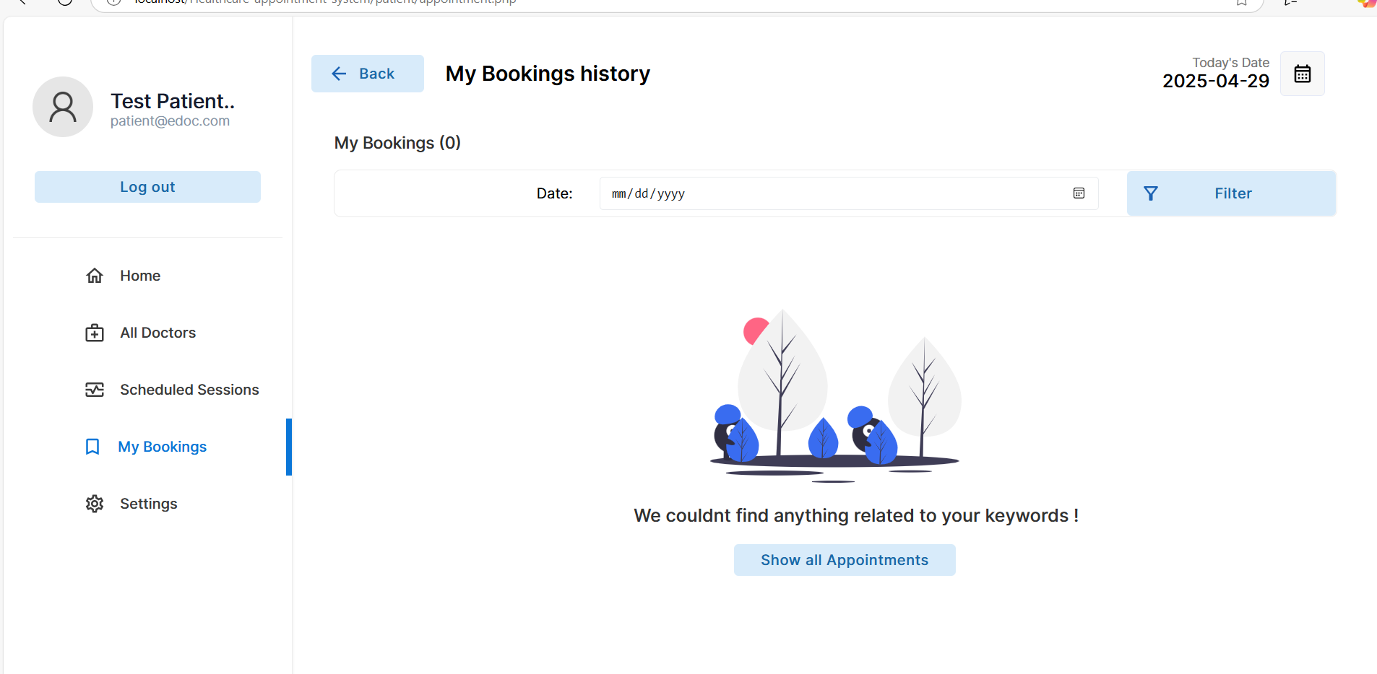

**Setting options for the patient**

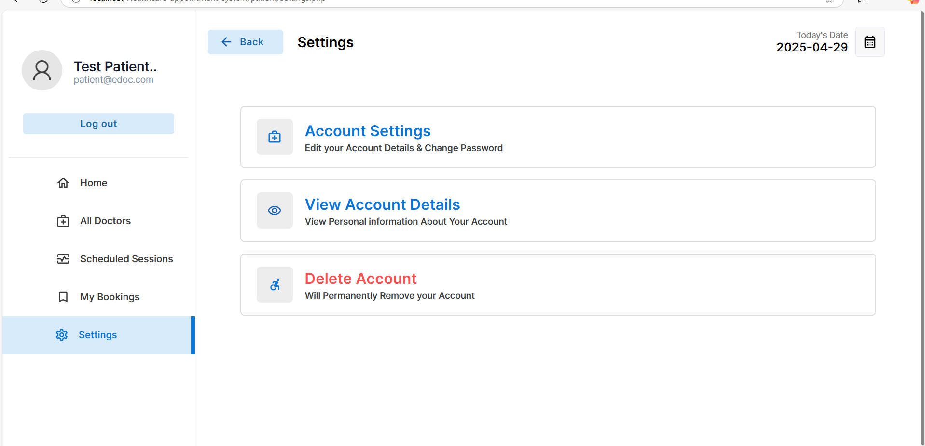

**Patients page to edit the information**

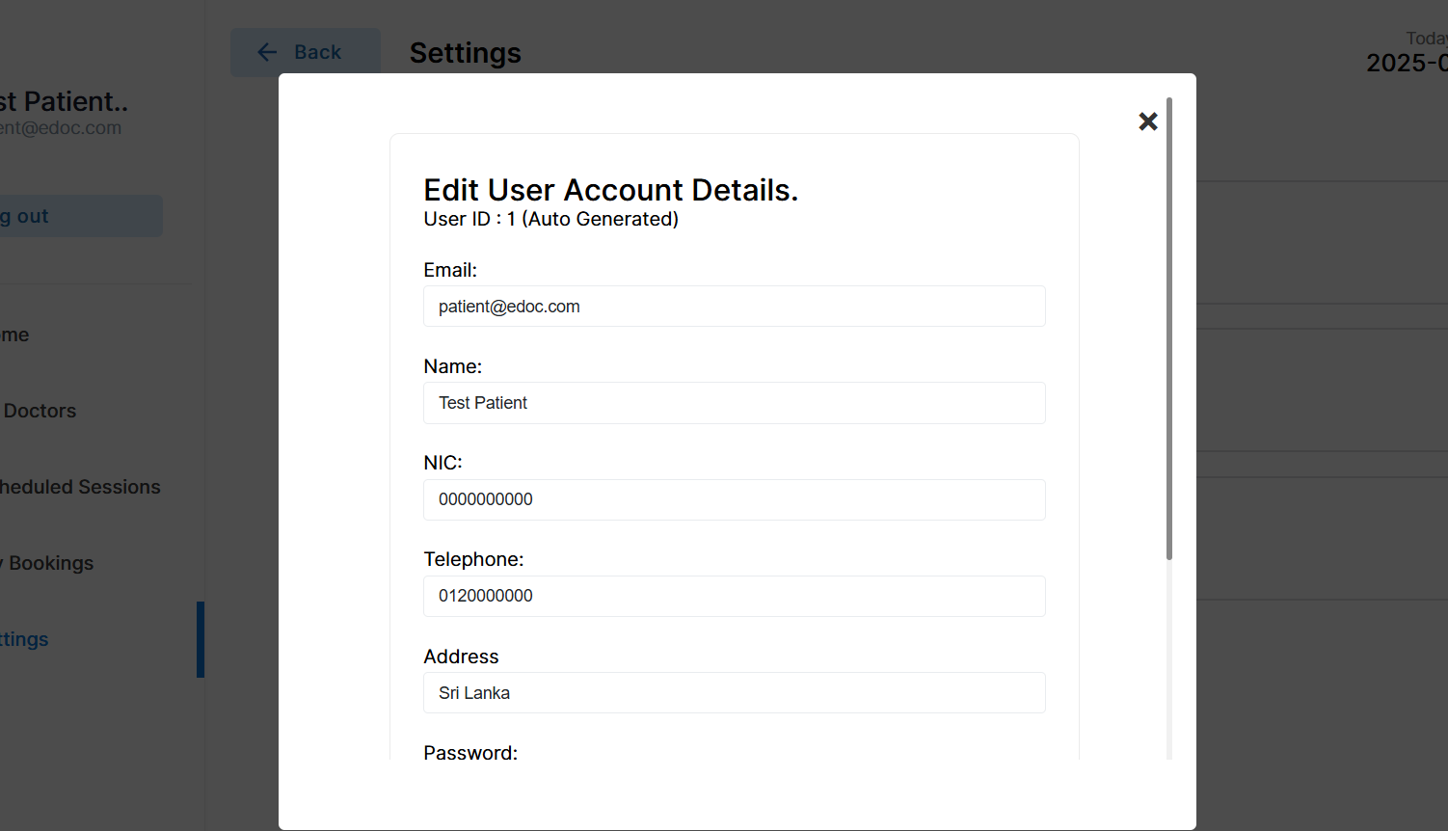

**Patients page to view the information**

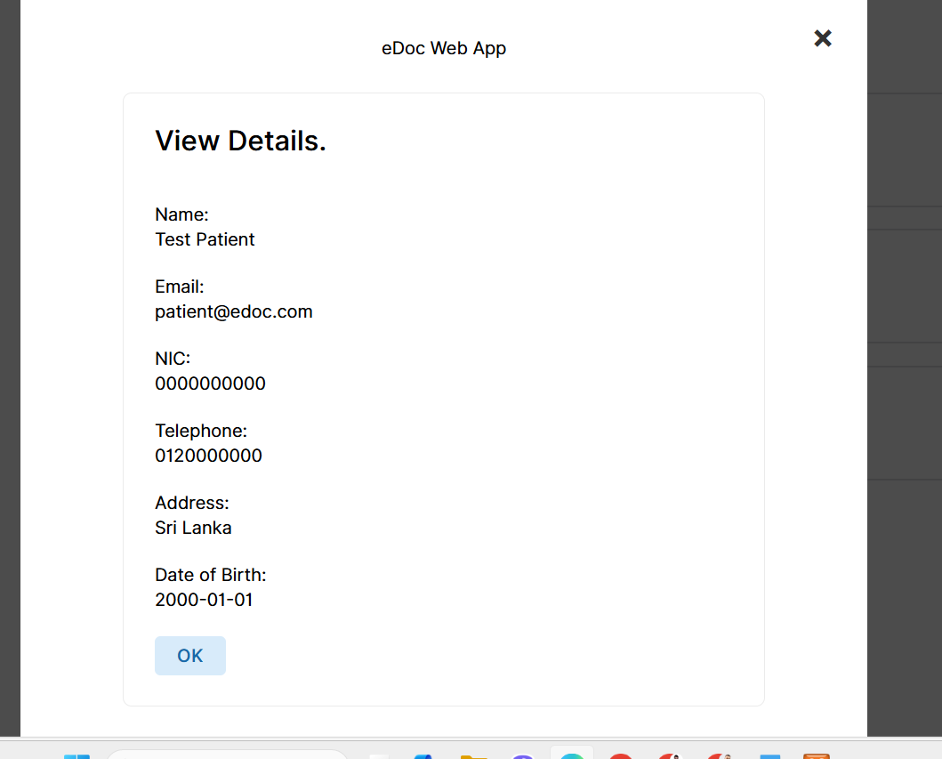

**Patients’ option to delete the account**

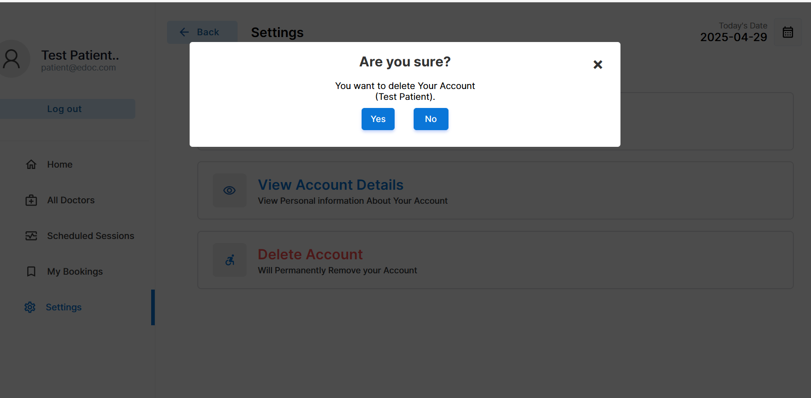

**Doctor home page to view**

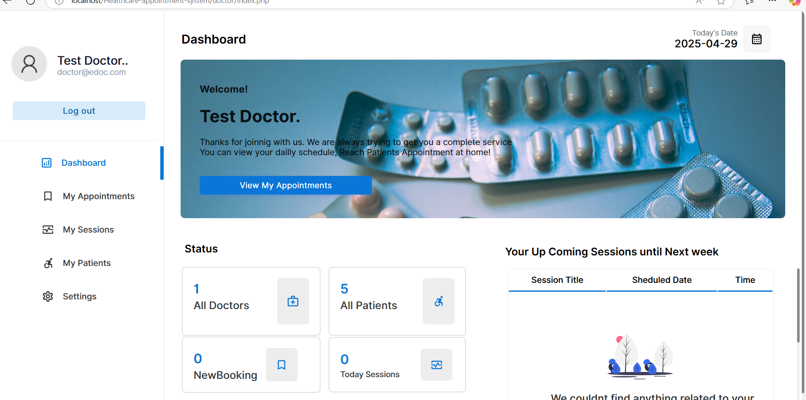

**Appointment page for doctor**

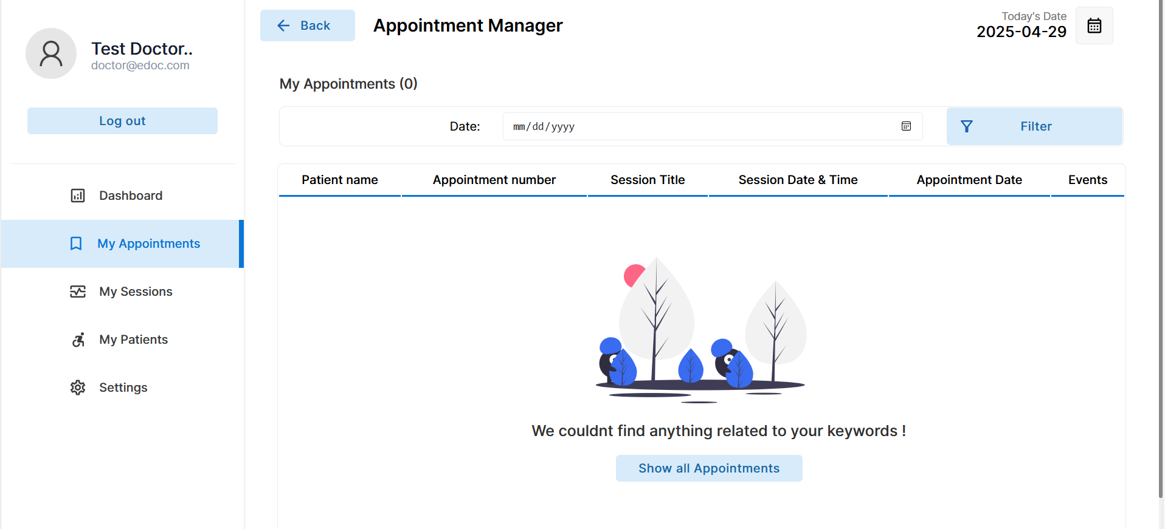

**Scheduled session page for doctors**

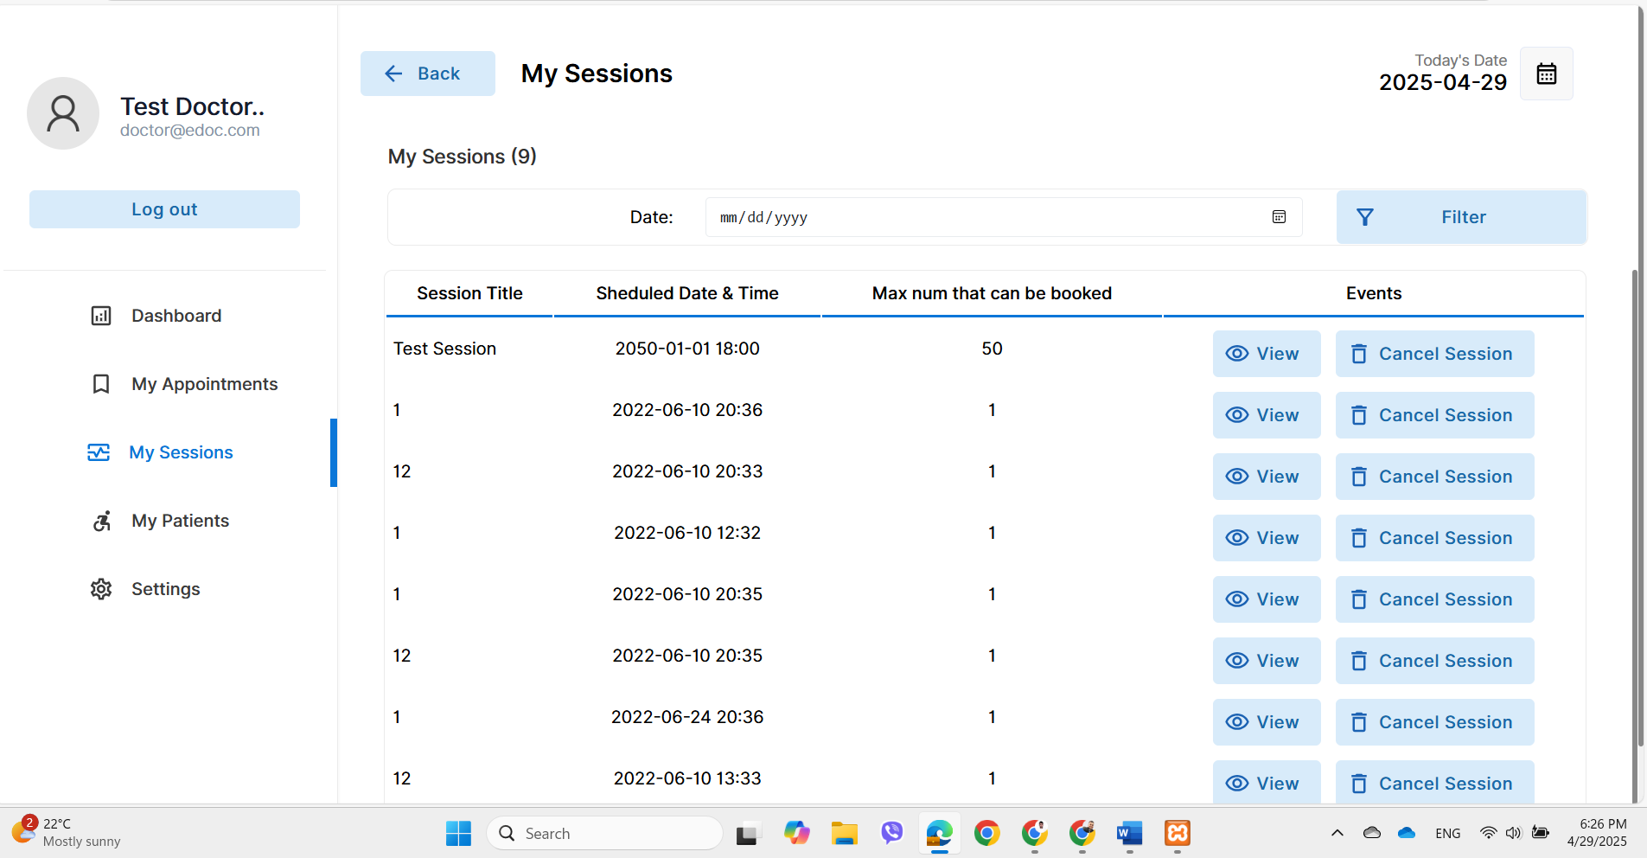

**Patients’ history page for doctor**

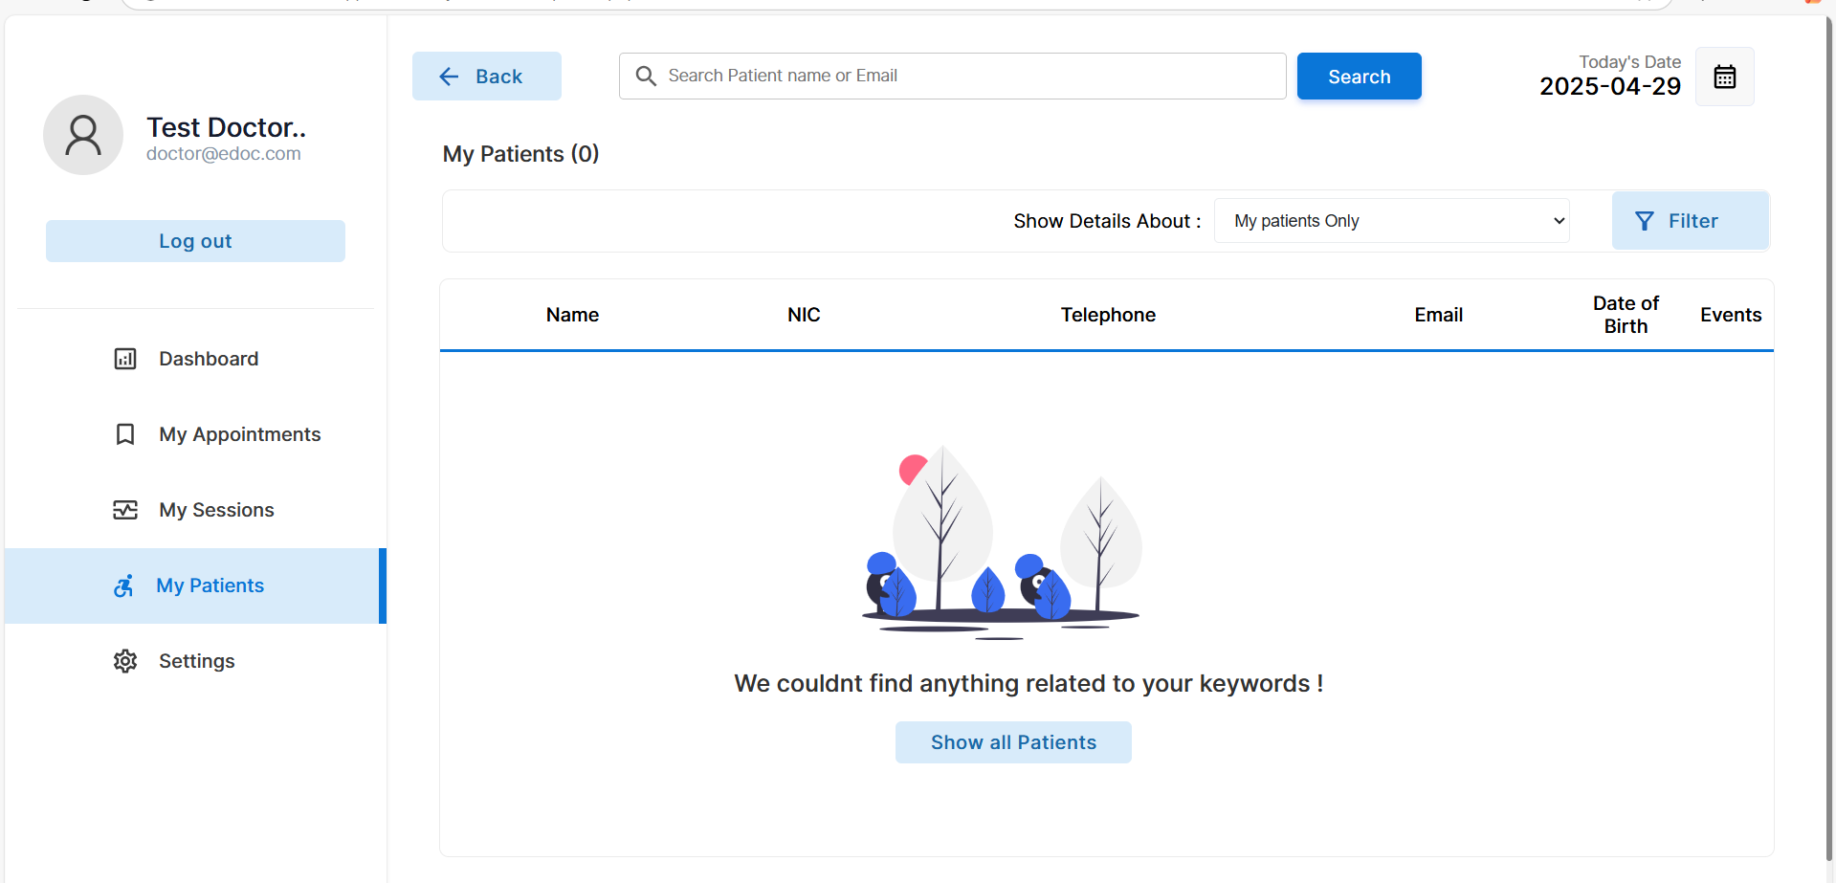

**Account setting page for the doctor**

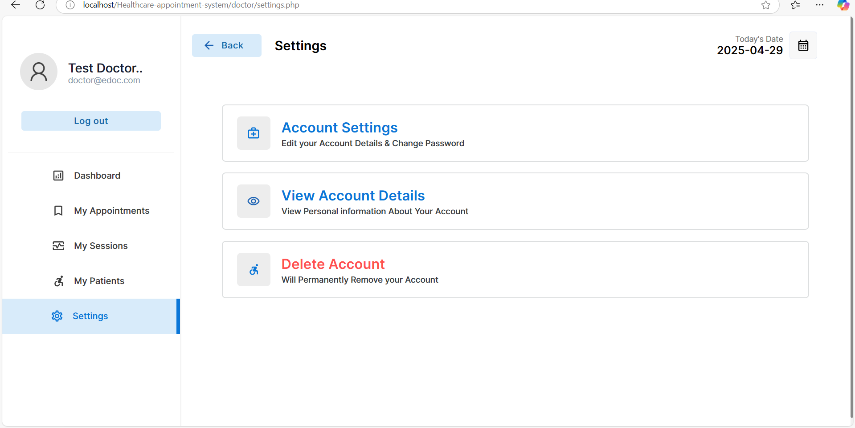

**Home page for admin**

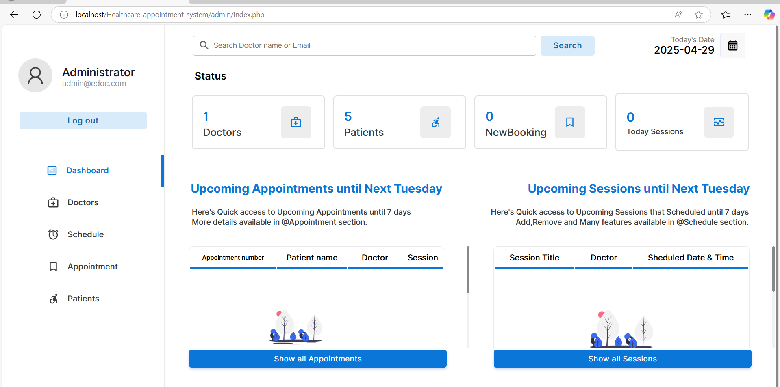

**Doctor details page for admin**

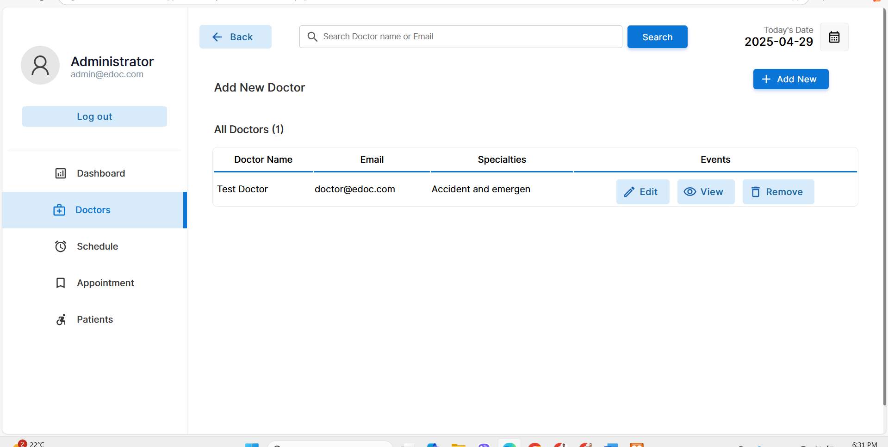

**Schedule manager page for admin**

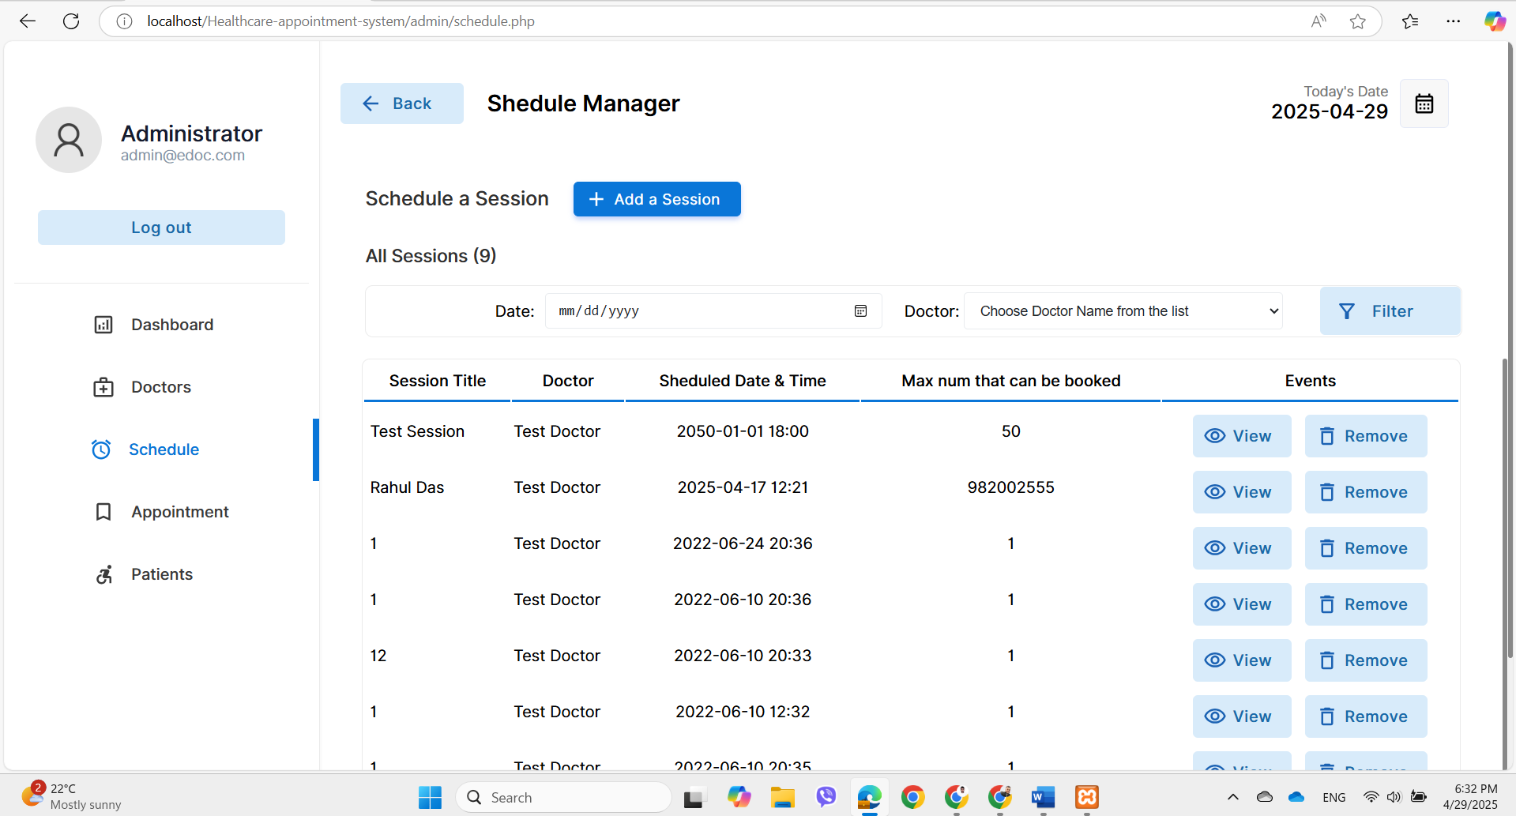

**Appointment management page for the admin**

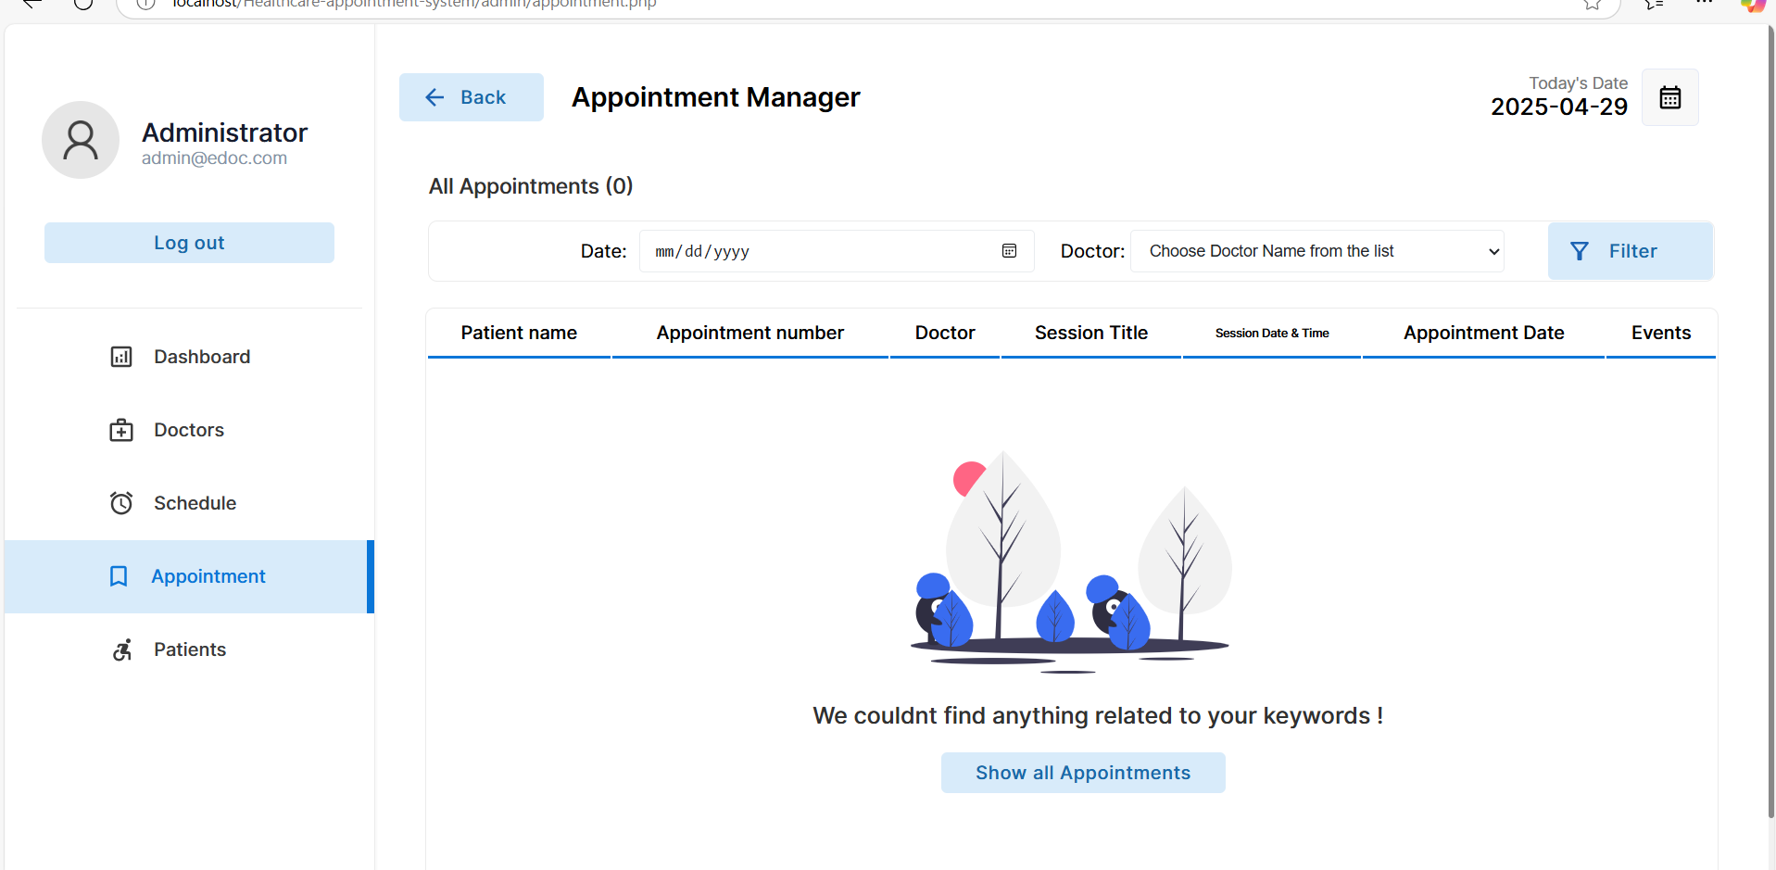

**Patient details page for admin**

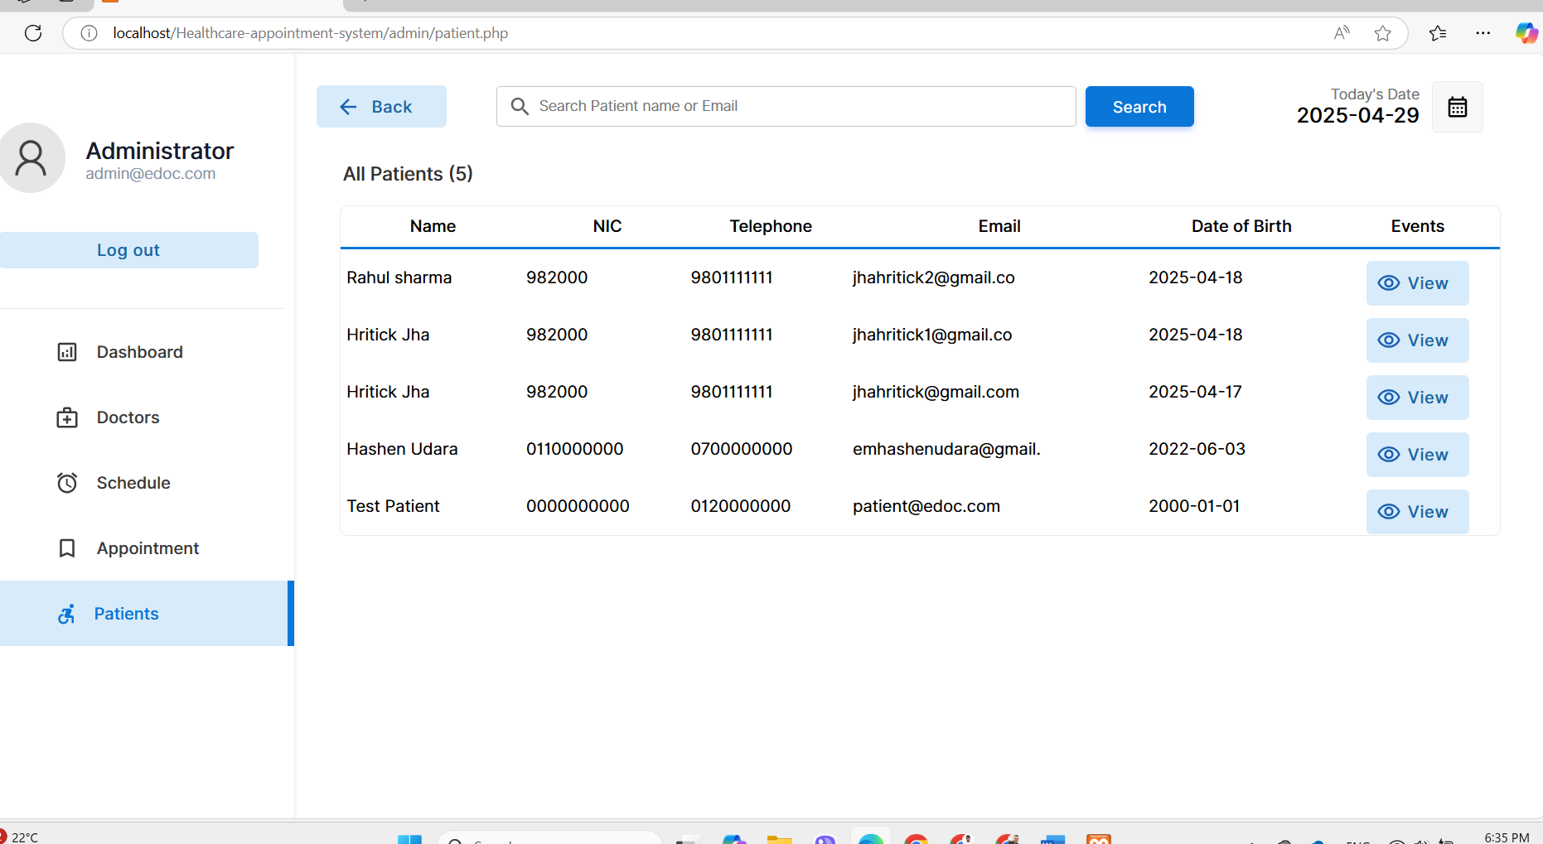

**View page of the activities for the admin**

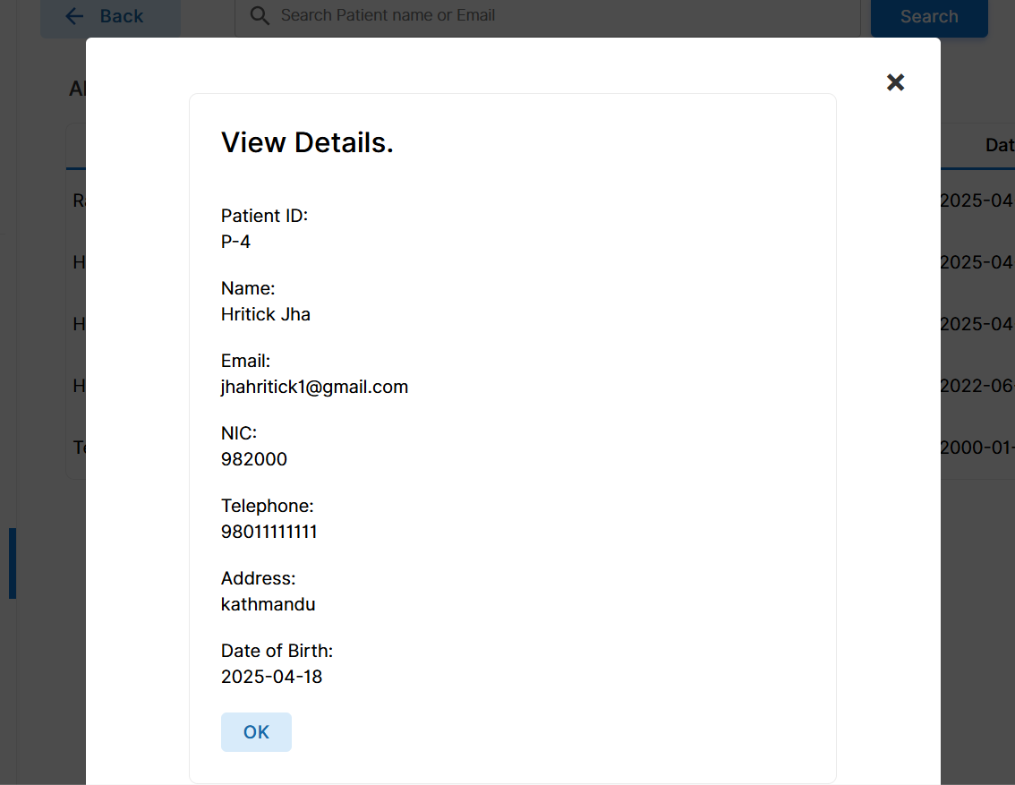

**Application Maintenance**

Application maintenance is the ongoing process of enhancing, ensuring, and the updating healthcare data analytics systems that have already been put into the place. These include fixing the problems, adding fresh data from the healthcare sector to the models, improving the performance, adapting to the changes in the regulations, and considering user input. Application maintenance, which accounts for the significant portion of the total lifespan cost of the software and data-driven systems, is essential to the success of long-term projects (Sommerville, 2016).

Numerous tasks, many of which are part of web application maintenance, are necessary for the ongoing health and the operation of the web-based systemWeb application maintenance is essentially a challenging process to maintain security, functionality, and user happiness in the always changing digital environment. An explanation Maintenance Status Resolving process issues Making improvements to the website and improving its usability in the application.

**Implementation issues and challenges**

The efficiency, precision, and uptake of the data science and the analytics solutions in the healthcare industry may be the impacted by a number of the important obstacles. To solve these problems, Raghupathi and Raghupathi (2014) state that the multidisciplinary strategy with the strong data governance, effective stakeholder participation, and continuing evaluation is necessary to ensure long-term success.

There are certain difficulties while using Visual Studio Code (VS Code) because online applications are made using an Integrated Development Environment (IDE). Despite these obstacles, creating web apps can be effective and successful provided these issues are resolved and the advantages of Visual Studio Code are utilized.

**Product evaluation**

Product evaluation, as the used in the healthcare data science and analytics efforts, is the process of the evaluating how well a solution—such as the dashboard, predictive model, or reporting tool—achieves its goals, such the generating insights and spotting patterns. Important features include the functionality, accuracy of the results, ease of use for the medical experts, performance with large datasets, and user satisfaction in the general.

The finished project was examined to make sure it fulfilled predetermined goals and the contained no significant mistakes. A working prototype was created by completing necessary activities, such as sending and receiving data to the server, laying the groundwork for further the application development. Despite several limitations due to the time constraints, the prototype was effective, navigable to the simple to use. Among the crucial tasks that were accomplished effectively were dashboard to the viewing, appointment scheduling, login, registration, settings management, and logout.

**Project evaluation**

In the field of the healthcare data science, the project is the evaluation comprises assessing how well the project met its the initial goals, adhered to the timelines, and yielded noteworthy of the outcomes. Stakeholder satisfaction, data accuracy, efficacy, goal achievement, and system in sustainability are all critical components. By carrying out thorough assessments, businesses can strengthen data governance, enhance future initiatives, and incorporate analytics programs with a more all-encompassing healthcare strategy (Kerzner, 2017).

While ensuring that into the Agile Methodology's essential are the elements were followed, the project was finished. Every stage of the process monitors the product's development, and the finished product is based on a prototype. At this stage, the project's efficient and systematic completion depended heavily on project management techniques and frequent meetings with the supervisor. Setting priorities and allocating time for critical tasks are considerably more crucial than effective time management. Finding materials and deciding which libraries to use were difficult.

**Communication plan**

A communication plan is to describe how stakeholders will exchange information through the a healthcare data science project. It involves are the informing the accountable parties, to the intended audience, to the channels (emails, reports, and meetings), and the frequency of communication. Healthcare analytics are the projects are the include reports on data insights, model performance, and compliance updates.

Projects cannot be completed successfully or on schedule without a clear to the project management plan and the effective communication. Frequent communication with the managers guarantees efficient development and timely resolution of issues.

|  |  |  |
| --- | --- | --- |
| Name | Position | Email |
| Shiva prasad Nepal | supervisor | snepal@thebritishcollege.edu.np |

**Summary and Conclusion**

**Summary**

This study investigates the use of analytics to the and data science to find important trends in the healthcare industry. To produce relevant insights, the team are the collected, analyzed, and visualized healthcare data using Python, Power BI, Excel, and Jupyter Notebook. Planning and development were aided by platforms such as Microsoft Project and to the Visual Studio Code, while wireframes, flowcharts, and the system layouts were produced using design tools like Figma and draw.io. To guarantee compliance and dependability, a great deal of the manual and unit testing was carried out during the deployment phase. Issues with user adoption, privacy, and data integration were found and resolved.

The doctors' appointment web application seeks to the revolutionize Nepal's healthcare by the industry by streamlining appointment scheduling and the accelerating service delivery through a single, user-friendly platform. Digital record-keeping to the and enhances to the service continuity, and automated to the reminders decrease missed are to the appointments. Healthcare workers may be able to focus more on the patient care are to the because of the app's to the multilingual support and user-friendly design, to the which promote inclusivity to the and reduce administrative tasks.

**Conclusion**

Using analytics is the data science in the healthcare to the industry has the potential to the revolutionize patient outcomes, to the market trends, and the strategic decision-making. This study effectively illustrates robust tools such as Python, Excel, and Power BI can be applied to the structured data analysis to identify significant patterns in the medical data. With thorough design, testing, and stakeholder interaction, to the project are the successfully tackles issues including data security, integration complexity, and the user acceptance. The finished products, which include tested models, are interactive dashboards, and understandable visualizations, show that they are scalable and dependable. If the system is continuously improved and to the maintained, it will continue to offer benefits and adapt to the shifting healthcare circumstances.

In conclusion, the doctor appointment of the web application is the to the improves the entire patient experience in Nepal's healthcare system by the to the increasing efficiency and the accessibility. Improved health outcomes and the more modern, equitable system are to the result from overcoming logistical obstacles and to the developing inclusive, digital healthcare delivery.

**Recommendation**

Integrating high-quality data with strong governance should be your priority if you want to enhance healthcare analytics in the future. To ensure that the products to the meet the real demands and are embraced by the customers, promote collaboration across to the stakeholders. With automatic monitoring, you can keep the model accurate even as the healthcare trends change. Develop multilingual to the mobile applications and incorporate them with health information systems to increase accessibility. Use awareness efforts to advertise the app and ensure that to the data security is strong to build confidence. Establish the feedback mechanism to promote continuous improvement and patient-centered treatment.

**Future Enhancement**

To expand predictive models for precise forecasts and with the enhance healthcare data analytics and incorporating real-time data. To improve usability, to enable mobile access and role-based dashboards. Investing in advanced, scalable technologies over the long run will enhance response to new health issues.

# References

* Cukier, K., & Mayer-Schönberger, V. (2013). *Big Data: A Revolution That Will Transform How We Live, Work, and Think*.
* Few, S. (2013). *Information Dashboard Design: The Effective Visual Communication of Data*.
* Jiang, F., et al. (2017). Artificial Intelligence in healthcare: Past, present and future. *Stroke and Vascular Neurology*.
* Krumholz, H. M. (2014). Big Data and New Knowledge in Medicine. *The New England Journal of Medicine*.
* Marz, N., & Warren, J. (2015). *Big Data: Principles and Best Practices of Scalable Real-time Data Systems*.
* McKinney, W. (2021). *Python for Data Analysis*.
* Obermeyer, Z., & Emanuel, E. J. (2016). Predicting the Future. *The New England Journal of Medicine*.
* Raghupathi, W., & Raghupathi, V. (2014). Big data analytics in healthcare: Promise and potential. *Health Information Science and Systems*.
* Shickel, B., et al. (2018). Deep learning in biomedical informatics. *Journal of Biomedical Informatics*.
* Topol, E. (2019). *Deep Medicine: How Artificial Intelligence Can Make Healthcare Human Again*.
* Wang, Y., et al. (2018). Big data applications in healthcare sector. *Health Informatics Journal*.
* Cukier, K., & Mayer-Schonberger, V. (2013). *Big Data: A Revolution That Will Transform How We Live, Work, and Think*.
* Few, S. (2013). *Information Dashboard Design: The Effective Visual Communication of Data*.
* Jiang, F., et al. (2017). Artificial Intelligence in healthcare: Past, present and future. *Stroke and Vascular Neurology*.
* Krumholz, H. M. (2014). Big Data and New Knowledge in Medicine. *The New England Journal of Medicine*.
* Marz, N., & Warren, J. (2015). *Big Data: Principles and Best Practices of Scalable Real-time Data Systems*.
* McKinney, W. (2021). *Python for Data Analysis*.
* Obermeyer, Z., & Emanuel, E. J. (2016). Predicting the Future. *The New England Journal of Medicine*.
* Raghupathi, W., & Raghupathi, V. (2014). Big data analytics in healthcare: Promise and potential. *Health Information Science and Systems*.
* Schickel, B., et al. (2018). Deep learning in biomedical informatics. *Journal of Biomedical Informatics*.
* Topol, E. (2019). *Deep Medicine: How Artificial Intelligence Can Make Healthcare Human Again*.
* Wang, Y., et al. (2018). Big data applications in the healthcare sector. *Health Informatics Journal*.
* Anon., n.d. *Introduction to data analysis handbook.* s.l.:Migrant & Seasonal Head Start.
* Anon., n.d. *Introduction to Data analyst.* s.l.:s.n.
* Hasan, S. J. M. J. G. N., n.d. *Methodologies for designing healthcare analytics solutions: A literature analysis,* s.l.: Victoria University, Australi.
* Juliana Castaneda1, L. C. S. B. A. T., January-June 2023, 81-128. *Data science, analytics and artifcial intelligence in,* s.l.: Data science, analytics and artifcial intelligence in e-health.
* Kang Chao a, M. N. I. S. b. I. A. b. R. R. F. b. A. A. b. M. M. S. b., 2023 Aug 31. *Big data-driven public health policy making: Potential for the healthcare industry.* [Art] (National Library of Medicine).
* Kazadi, J. K., May 27, 2024. *Data Science and Analytics in Healthcare,* Germany: Datenwissenschaft, Analytik, Gesundheitswesen, Ethik.
* Nwoke, J., 5th Sep, 2024, Published: 18th Sep, 202. *Healthcare Data Analytics and Predictive Modelling: Enhancing Outcomes in Resource Allocation, Disease Prevalence and High-Risk Populations.* [Art] (Thomas Jefferson University, Philadelphia, Pennsylvania, United States).
* SHARMA, D. S. K., n.d. *RESEARCH METHODOLOGY AND,* s.l.: International Centre for Distance Education &.
* Ślęzak, A., 2022 Jan 6. *The use of Big Data Analytics in healthcare.* [Art] (National Library of Medicine).
* Ślęzak, K. B. &. A., 06 January 2022. *The use of Big Data Analytics in healthcare.* [Art].